LECTURER NOTES

TRANSPORTATION ENGINEERING
Diploma in Civil Engineering

5th Semester


SSIT POLYTECHNIC
KALAKAD,MAYURBHANJ

NOTE PREPARED BY :-
Er. PRAMOD KUMAR BEHERA, (DEPT. OF CIVIL ENGG.)

HIGHWAY ENGINEERING

SYLLABUS
Contents: Theory

Unit | Name of the Topic | Hours
UNIT –I  UNIT –II  UNIT –III  UNIT –IV  UNIT –V | - Overview of Highway Engineering  Role of transportation in the development of nation,  Scope and Importance of roads in India and its’  Characteristics.  • Different modes of transportation – land way,  waterway, airway. Merits and demerits ofroadway  and railway;  • General classification of roads.  • Selection and factors affecting road alignment.)  - GEOMETRICAL DESIGN OF HIGHWAYS  Camber: Definition, purpose, types as per IRC –  recommendations.  Kerbs: Road margin, road formation, right of way.  Design speed and various factors affecting design  speed as per IRC – recommendations.  10  Gradient: Definition, types as per IRC –  Recommendations.   Sight distance (SSD): Definition, types IRC –  recommendations, simple numerical.   Curves: Necessity, types: Horizontal, vertical curves.   Extra widening of roads: numerical examples.   Super elevation: Definition, formula for calculating  minimum and maximum Super elevation and method of  providing super-elevation.   Standards cross-sections of national highway in  embankment and cutting.  - CONSTRUCTION OF ROAD PAVEMENTS  Types of road materials and their Tests – Test on  aggregates-Flakiness and Elongation In- dex tests,  Angularity Number test, test on Bitumen-  penetration, Ductility, Flash and Fire point test and  Softening point test.  • Pavement – Definition, Types, Structural  Components of pavement and their functions  • Construction of WBM road. Merits and demerits of  WBM & WMM road.  • Construction of Flexible pavement / Bituminous  Road, Types of Bitumen and its proper- ties,  Emulsion, Cutback, Tar, Terms used in BR-prime  coat, tack coat, seal coat, Merits andDemerits of BR.  • Cement concrete road -methods of construction,  Alternate and Continuous Bay Method, Construction  joints, filler and sealers, merits and demerits of  concrete roads. Types of joints.  - Classification of Indian Railways, zones of Indian  Railways   • Permanent way: Ideal requirement, Components; Rail  Gauge, types, factors affecting selection of a gauge.   • Rail, Rail Joints - requirements, types.   • Creep of rail: causes and prevention.   • Sleepers - functions and Requirement, types - concrete  sleepers and their density   • Ballast - function and types, suitability.   • Rail fixtures and fastenings – fish plate, spikes, bolts,  keys, bearing plates, chairs-types of anchors and anti-  creepers.  - Track geometrics, Construction and Maintenance | 05 Hrs  10 Hrs  10 Hrs  10 Hrs  10 Hrs

UNIT- I
HIGHWAY ENGINEERING
Chapter -1

INTRODUCTION
- GENERAL
Transportation is the movement of people or goods from one place to another. Transport is important since it enables trade between people, which in turn augment economic growth and foster civilizations. The transport system comprises of highways or roadways, Railways, water ways and air ways.
Road ways include highways, city roads, village roads, feeder roads and ghat roads. Roadways provide maximum service to one and all. It is possible to provide door to door services only by road.

DEVELOPMENT OF ROADS IN INDIA
Transportation is one of the infrastructures of a country. Transportation helps in economic, industrial, social and cultural development of a country. Transportation is very important for the economic development of any region since commodities produced, like food, clothing, industrial products, medicine need transport at all stages from production to distribution. It is also essential for strategic movement in emergency for defence of the country and to maintain better law and order. Transportation also helps in tourism development.
Road transport is one of the most common modes of transport. Roads in the form of track ways, human pathways etc. were used even from the pre-historic times. Since then many experiments were going on to make the riding safe and comfort. Thus road construction became an inseparable part of many civilizations and empires.
The history of highway engineering gives us an idea about the roads of ancient times. Roads in Rome were constructed in a large scale and it radiated in many directions helping them in military operations. Thus they are considered to be pioneers in road construction.
In India the Mauryan dynasty rulers and Harsha Vardhana took much interest in the development of road system as they were able to appreciate the importance of road in terms of strategic and economical development of country. In the later period the Mughal emperors paid much importance in counstrucion of roads; Patna-Kabul, Delhi-Surat, Delhi-Golconda, Golconda-Bijapur, Bijapur-Ujjain and Surat-Maulipatanam are some of the notable highways developed by them.

Cross slope

Side drain

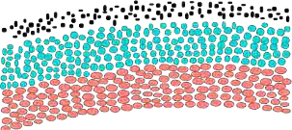

Figure : 1.1.2.1 British Road
4.5 m
Compacted Subgrade slope 1:36 50mm
Broken Stones, 100mm thick 37.5mm Broken Stones, 100mm thick Surface Course 20mm, 50mm thick

BRITISH ROAD
The British government also gave importance to road construction. The British engineer John Macadam introduced what can be considered as the first scientific road construction method. Stone size is an important element of Macadam surface formation. By empirical observation of many roads, he came to realize that 250 mm layers of well compacted broken angular stone would provide the same strength and stiffness and a better running surface than an expensive pavement made on large stone blocks. Thus he introduced an economical method of road construction.
The mechanical interlock between the individual stone pieces provides strength and stiffness to the course. But the inter particle friction abraded the sharp interlocking faces and partly destroy the effectiveness of the course. This effect was overcome by introducing good quality interstitial finer material to produce a well-graded mix. Such mixes also proved less permeable and easier to compact. A typical cross section of British roads is given in Figure 1.1.2.1.

MODERN ROADS
The modern roads by and large follow Macadam‘s construction method. Use of bituminous concrete and cement concrete are the later developments. Various advanced and cost-effective construction technologies are used. Development of new equipments help in the faster construction of roads. Many easily and locally available materials are tested in the laboratories for their suitability and then used on roads for making economical and durable pavements.

MODES OF TRANSPORTATION
Scope of transportation system has developed very largely. Population of the country is increasing day by day. The life style of people began to change. The need for travel to various places at faster speeds also increased. This increasing demand led to the emergence of other modes of transportation like railways and airways. While the above development in public transport sector was taking place, the development in private transport was at a much faster rate mainly because of its advantages like accessibility, privacy, flexibility, convenience and comfort. This led to the increase in vehicular traffic especially in public road network. Thus road space available was becoming insufficient to meet the growing demand of traffic and congestion started. In addition, chances for accidents also increased. This has led to the increased attention towards control of vehicles so that the transport infrastructure could be used optimally. Various control measures like traffic signals, providing roundabouts and medians, limiting the speed of vehicle at specific zones etc. were implemented.
With the advancement of better roads and efficient control, more and more investments were made in the road sector especially after the world wars. These were large projects requiring large investment. For optimal utilization of funds, one should know the travel pattern, travel behavior and the future economic growth potential of the region. This has led to the emergence of transportation planning and demand management.

NAGPUR PLAN
The British did not pay much attention in developing the new road system and in maintaining the existing roads. They paid special attention only on the roads which served their strategic and economic interest. During the post-war years there arose a great demand for better and more roads to cope with the increased vehicular traffic throughout the country. The Government of India appointed ―The Road Development Committee‖ popularly known as the ―Jayakar Committee‟ in 1927 was a major landmark in the history of road in India. The Committee was emphatic regarding the inadequacy of the Indian road system and urged that further development of the system was desirable for the general welfare of the country and economic growth as a whole. As a sequel to the Jaykar Committee recommendation, The Indian Road Congress came into being in April, 1934, which convened a conference of chief engineers at Nagpur in 1943. It was the first time, at this conference, that the question of road development was considered comprehensively and in a scientific manner. A long term plan,
opularly called the Nagpur Plan envisaged the construction of new roads besides the improvement of some existing ones. The plan classified the roads into four classes:
- National Highways
- Provincial or State Highways
- District Roads
- Village Roads
From 1919 to 1947, the provinces remained solely responsible for the construction and maintenance of all roads. Under the new constitution of India, the national highways were made a central subject, and the central government had statutorily taken over the roads classified as national highways, vide the ―National Highways Act, 1956‖. For the execution of national highway scheme the central government created the roads wing in the department of transport, which as per the suggestion of Nagpur conference was made responsible for co-ordination and control, drafting of standards and specifications, setting priorities, general administration and inspection. Nagpur plan covered the period from 1943 to 1961 and laid the foundation for the functional classification of road network and criteria for road construction and connectivity bot h in developed and undeveloped area of our country. This was followed by two more 20 year road development plans covering the periods 1961-81 and 1981-2001 popularly known as ‗ Bombay Plan‘ and ‗ Lucknow Plan‘, respectively. These plans have served as sound reference framework for the central and the state governments to formulate the further road plan (IRC, 1984) for road development. The government of India changed the development strategy in 1991 by introducing a series of reforms and structural changes with a view to integrating it with the global market and economy. The areas which were traditionally i n the domain of the public sector were thrown open to private sector. The rationale was that while the government provides a strong policy su pport and regulatory leadership, the private sector would bring in dynamism and efficiency in the construction of the road transport system. The above policy serves both social and economic aspects in road construction. In view of these developments ―Road Development Plan: Vision 2021‖ was prepared in 2001 by the Ministry of Road Transport and Highways (MORTH), Government of India.

RIBBON DEVELOPMENT:
Any development that takes place alongside a highway without proper plan and design develops chaotic traffic and pedestrian movements, leading to accidents. This type of linear development is known as ribbon development.

DISADVANTAGES OF RIBBON DEVELOPMENT:
        - Ribbon development strangles the road system and creates ugly and undesirable spots where there might have been scenic surroundings.
        - Increase in congestion on the highways. The commercial establishments located along the main highway attract heavy two wheeler traffic of the industrial workers going to work in the morning and returning in the evening. The net result is that local traffic, of a predominantly mixed character, claims heavy demand on the road space and gets its major share to the detriment of through traffic emanating from the towns and entering the towns.
        - The congestion caused by mixed traffic increases the probability of accidents. The presence of a large number of advertisements and sign boards on roads is an important source of driver distraction leading to numerous accidents.
        - Reduces the level of service of the main highway.
        - Problem of encroachments.
        - Due to ribbon development, widening of highways becomes a difficult task, leading to acquisition of properties at exorbitant cost. If future traffic has to be catered to, it is necessary that adequate control is exercised on linear growth.
        - As already pointed out that some of the legislations already holding field discourage ribbon development and in any case unplanned ribbon development.
Considering the above mentioned difficulties in road transport system there should always be a proper plan preferably a master plan for laying new roads and for the improvement of existing road transport system.

ADVANTAGES OF ROADS:
As compared to the railways, the road transport system has definite advantages which can be summarized as follow:
- Road transport is quicker, more convenient and more flexible. It is particularly
good for short distance travel for movement of goods. Motor vehicles can easily collect passengers and goods from anywhere and take them to wherever they want to be dropped.
- Door-to-door collection and delivery are possible in the case of road transport. But in the case of railways, the lines are fixed and the railways do not have the flexibility of the roadways. Passengers and goods will have to be taken to the railway stations.
- Roads are a necessary complement to railways. India is a country of villages and it is only roads which can connect villages and railways can connect towns. The railway stations will have to be properly served by a network of feeder roads. Only through these roads the railways can receive their passengers and goods. If railways are essential for the movement of goods and people for long distances, road transport is essential for such movement for short distances. Roads and railways are, therefore, not competitive but complementary to each other.
- Road transport is of particular advantage to the farmers. Good roads help the farmers to move their products, particularly the perishable products; like vegetables, quickly to the market and towns. Only by developing the road system, the farmer can be assured of a steady market for his products. It is the road system which brings the villagers into contact with the towns and to expose them to the new ideas and the new systems.
- Roads are highly significant for the defense of the country. For the movement of troops, tanks, armored cars, and field guns etc. roads are essential. The great importance given to the construction of border roads to facilitate the movement of troops for the protection of the northern borders.
- It is easy and cheap to construct and maintain roads compared to other mode of transport.
- Roads can negotiate high gradients and sharp turns which railways cannot do. As such, roads can be constructed in hilly areas also.
Due to above-mentioned advantages, the road transport has become very popular and its share is constantly increasing.

IMPORTANCE OF ROADS IN INDIA:
Connectivity provided by roads is perhaps the single most important determinant of well-being and the quality of life of people living in an urban area. The objective of the innumerable government programmes aimed at rural development, employment generation and local industrialization to a large extent due to the construction and connectivity of the road transport system. There is a considerable body of evidence that demonstrates that the lack of links between rural roads with other state and national highway result in less economic growth that leads to poverty and poor quality of life. Road investment contributed directly to the growth of agricultural output, increased use of fertilizer and establishment of commercial banks.

REQUIREMENTS OF AN IDEAL ROAD:
The important points to be kept in mind for the design of highways of various types are as follows:
- It should be free from being submerged during floods and thus should be available for safe movement of traffic at all times.
- It should be provided with easy gradient.
- It should contain intelligently erected traffic signs and should make sufficient provisions for the safety of pedestrians and vehicles.
- It should grant various amenities to road users such as grass verges, sufficient lighting, watering and fuelling places at regular intervals, shady avenues, parking facilities in city areas, etc.
- It should possess good alignment, directness and visibility.
- The curves along the road should be properly designed and they should be free from blind corners.
- The formation of road, either natural or prepared, should be stable enough to carry the foundation and traffic load.
- The foundation depth should be adequate for effectively distributing traffic load over a sufficient area of formation to keep the intensity of load within the safe permissible limits of the soil.
- The road surface should be suitable for the general character of traffic and it should possess characteristics such as:

  - onomical in construction and maintenance costs,
  - even and smooth, but not slippery,
  - hard, durable with uniform wear,
  - neither dusty nor muddy and easy for cleaning and repairing,
  - noiseless especially near hospitals, nursing homes and public institutions, etc.,
  - offering the least resistance to traffic, etc.
- The surface of road should be impervious and impermeable to rain water.
- The width of road should be sufficient
- good drainage system to drain the water from the road surface

- Central research institute(CRRI):

CRRI was started by the central government in 1950. for the research work in the Highway engineering .CRRI is a series of laboratories under the council of science and industrial research in India. It offer the following service.

1.2 INDIAN ROAD CONGRESS (I.R.C.)
The Jayakar Committee was formed in 1927 to report on road conditions in India and give recommendations for development. It proposed that the central government take responsibility for road building because local governments could not handle it. The Indian Roads Congress (IRC) was created in 1934 as a forum for technical specialists, as recommended by the Jayakar Committee. The IRC sets recommended criteria for road design and construction across the country and works with the Ministry of Surface Transport. The Central Road Research Institute (CRRI) was established in 1950 to undertake highway engineering research, both basic and applied, advise organizations, and provide library services.
- Appointment of jayakar committee:
In 1927 central govt appointed an Indian road development committee under the chairmanship of M.R .Jayakar to report on the exiting road condition ,and suggestion for their future development .The jayakar committee submitted its report on 1928 with the recommendation that since the provincial government and the local bodies are not able to look after all the roads the road development in the country should be taken up by the Central Government.

Function of Indian Roads Congress:

it provides a form for expression of collective opinion of its member for all matter affecting the construction and maintenance of roads in India.

It promotes the use of the standard specification and pratice.

It provided with the suggestion for the better methods of planning designing construction.administration and maintenance of roads.

It conducts periodical meetings to discuss techinal problem regarding roads.

It makes the laws for the development and ,improvement and protection of the roads.

OBJECTS OF HIGHWAY PLANNING:
Following are the objects or purposes of highway planning:
- To assist the general planner for serving adequately whatever transportation demand is created by population growth, economic development and technological change.
- To create awareness of unforeseen events, conditions, changed policies and other current developments.
- To indicate the analysis for the establishment of financial and management policies required to implement sound decisions.
- To make optimum use of the existing conditions for working towards improvement so as to meet probable future requirements
- To prepare a plan in such a way that traffic operations are carried out efficiently and safely on the highway
- provide factual analyses leading to the determination of required physical development of the highway, road and street network.

1.3 IRC CLASSIFICATION OF HIGHWAYS
ROADS CLASSIFICATION CRITERIA
Apart from the classification given by the different plans, roads were also classified based on some other criteria. They are given in detail below.

BASED ON USAGE
This classification is based on whether the roads can be used during different seasons of the year.
  - All-weather roads: Those roads which are negotiable during all weathers, except at major river crossings where interruption of traffic is permissible up to a certain extent are called all weather roads.
  - Fair-weather roads: Roads which are negotiable only during fair weather are called fair weather roads.

BASED ON CARRIAGE WAY
This classification is based on the type of the carriage way or the road pavement.
  - Paved roads with hard surface: If they are provided with a hard pavement course such roads are called paved roads.(eg: stones, Water bound macadam ( WBM), Bituminous macadam (BM), concrete roads.
  - Unpaved roads: Roads which are not provided with a hard course of at least a WBM layer they is called unpaved roads. Thus earth and gravel roads come under this category.

CLASSIFICATION OF ROADS AS PER I.R.C (INDIAN ROAD CONGRESS)
Based on location and function, the Nagpur plan classifies the roads as
- National-highways (NH)
- State Highways(SH)
- Major district Roads (MDR)
- Other district roads (ODR) and
- Village Rods

- National Highways (NH): These are the main highways which connects ports, foreign highways, capital cities of large states and large industrial and tourist centre including roads of military importance. They are financed and constructed by central government. All the national highways are assigned the respective numbers. The highway Vijayawada and Pune, through Hyderabad is NH9. Nagpur – Hyderabad – Bangalore road denoted as NH7.
- State Highways (SH): These are important roads of a state. The state highways connect national highways of adjacent state, district headquarters and important cities within the state.
They are financed and constructed by the State government
- Major District Roads (MDR): These are important roads within district serving areas of production and market and connecting the main highways of a district.
- Other District Roads (ODR): These roads are serving rural areas of production and connectthem with market centre, Taluk headquarters, and other mainroads.
- Village roads: These are the roads connecting villages or group of villages with each other to the nearest road of a higher category. They are financed and constructed by panchayaths with the help of zilla parishads and State governments.

MODIFIED CLASSIFICATION OF ROAD SYSTEM BY THIRD ROAD DEVELOPMENT PLAN (1981 – 2001)
The roads in the countryare now classified in to three classes
1.Primary system 2.Secondary system 3.Tertiarysystem

Primary system consists of two categories of roads
  - Express ways and
  - National Highways (NH)

Express ways are separated class of highways with superior facilities and design standards meant for very high volume traffic. These permit only fast movingvehicles.

Thesecondary systemconsists
  - State highways (SH) and
  - Major District Roads

Tertiary systemconsists of
  - Other District Roads (ODR) and
  - Village Roads

CLASSIFICATION OF URBAN ROADS

The urban roads are classified as
        - Arterial Roads
        - Sub – arterial roads
        - Collectorstreets and
        - Local streets

Arterialand sub arterial roads are the streets primarilyfor through traffic.

UNIT-II

2. GEOMETRICAL DESIGN OF HIGHWAY
2.1 ROAD STRUCTURE:
- Sub soil
- Sub grade
- Base course
- Wearing course or Surface course
- Berm

i) SUB SOIL

Road structure consists of the following components as shown in the fig.1.3.2.

SUB GRADE:
The sub grade functions as a support to road surface and serves as a foundation. The life of road primarily depends on the stability and dryness of sub grade. Therefore considerable attention should be paid in the preparation of the sub grade.

BASE COURSE:

Base course is a layer made of granular material such as broken granite stone, natural gravel,

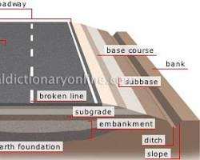
Cross sections of road structures

and boulder stone. It is a layer immediately under the weaning course. It is an important structural part of the road. It should be strong enough to bear the loads of the traffic. The material in a base course must be of extremely high quality. It must be well compacted.

FUNCTIONS OF BASE COURSE:
  - It reduces the traffic stresses on the sub grade and protects it.
  - Acts as a working platform for the construction of upper pavement layers.
  - Acts as a drainage layer by protecting the sub grade from wetting up.
  - Intercept the upward movement of water by capillary action.
  - It acts as a separating layer between subgrade and base course.

WEARING COURSE OR SURFACE COURSE:
Wearing course is the top most layer of a road which is in direct contact with the traffic. The purpose of the weaning course is to give a dense smooth riding surface with flexiblity. It resists the pressure exerted by tyres and withstands wear and tear due to the traffic. It acts as a water tight layer and prevents percolation of water.

RIGHT OF WAY
Right of way is the area of land acquired and reserved along its alignment for construction and development of a highway is known as right of way.

LAND WIDTH:
A minimum land width is prescribed for different categories of road. The below table gives the minimum width of right of way for different categories of road.

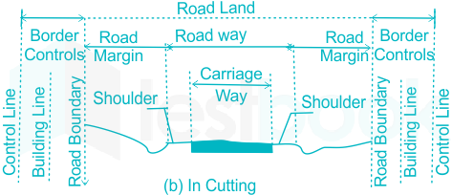

Requirement of right of way
There are chances of developments along its route and when it becomes necessary to have the
widening of road in future; it proves to be difficult and costly to acquire such developed lands along the boundary of road. Hence the appropriate width of land has to be acquired in the initial stage so that the road can be widened without serious difficulties when the occasion demands in future. The rights of ownership of road land are vested with the highway authority.
As a further precaution, restrictions are put up on the construction activities along the road and for this purpose, building lines and control lines are decided at suitable distance from the road boundary.
The owner of land along highway route has to leave a certain set back or margin from road boundary and he can construct the building up to that line only in his plot. This line is known as building line.
A further set back in the form of control line has to be maintained by the private land owners along the highway route and the development between the portion covered by the building line and control line is restricted by the concerned highway authority.
The right of way mainly depends on the importance of road and it is decided in such a way that the following components of road are suitably accommodated:
- availability of funds;
- cost of acquisition of lands;
- drainage systems;
- height of embankment or depth of cutting;
- side slopes of embankment or cutting;
- visibility considerations on curves;
- width of formation;
- width of land required for future development; etc.

FORMATION OF WIDTH:
The width of pavement or carriage way depends on the width of traffic lane and number of lanes. The carriage way intended for one line of traffic movement may be called as a traffic lane. The lane width is determined on the basis of the width of vehicle and the minimum side clearance provided for the safety. When the side clearance is increased there is an increase in speed of the vehicles and hence in increase in the capacity of the pavement. A width of 3.75 m is considered desirable for a road having single lane for vehicles of maximum width 2.44 m. For pavement having two or more lanes, width of 3.5 m per lane is sufficient.

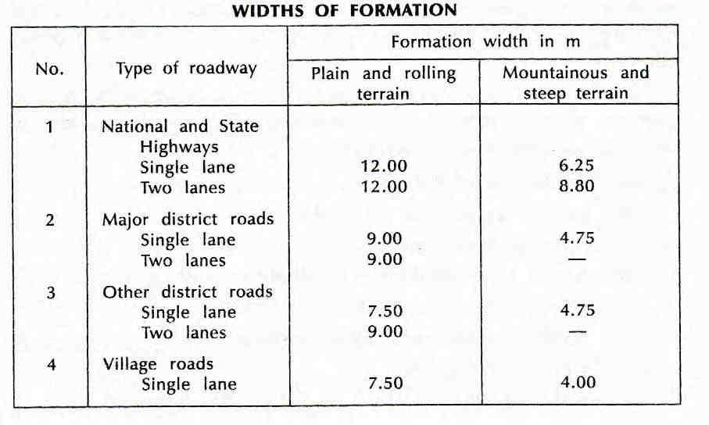
Table: FORMATION OF WIDTH

Table: 1.3.3 Road Classification and dimensions

Class of Road | Width of the Carriage Way
- Singlelane  - Two lanes, without raised kerbs  - Two lanes, with raised kerbs  - Intermediate carriage way  - Multilane pavement | 3.75m  7.0 m  7.5 m  5.5 m  3.5 m per lane

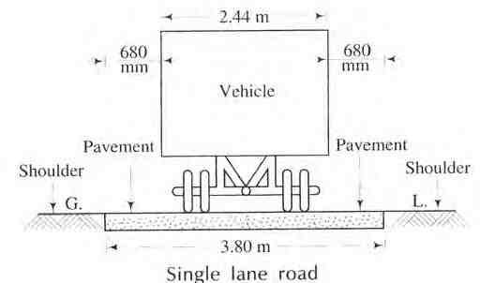

    - (a) Single and double lane Roadway

SHOULDERS:
Shoulders are provided along the road edge to serve as an emergency lane for vehicles to be taken out of the pavement. These also act as service lanes for vehicles that have broken down. The minimum shoulder width recommended by the IRC is 2.5 m. The shoulders should have sufficient strength to support loaded even in wet weather. The surface of the shoulder should be rougher than the traffic lanes so that the vehicles are discouraged to use the shoulder as a regular traffic lane.

1.3.3.2. CROSS SECTIONS OF ROADS:
The following figures shows the cross-section of road in embankment, cross-section of road in cutting, the typical cross-section of two-lane NH or SH in rural area , the typical cross-section of two- lane city road in Built up area
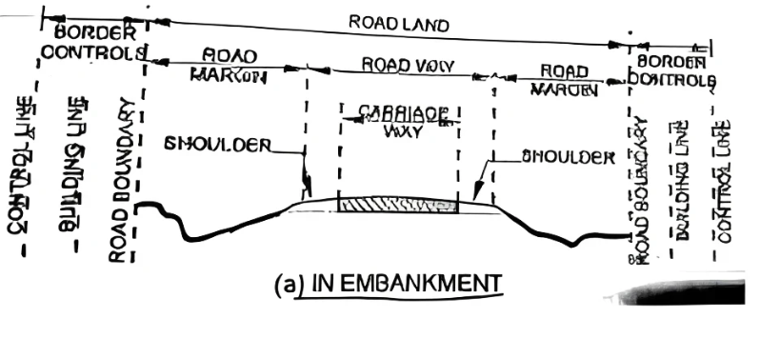

Cross section of road in cutting

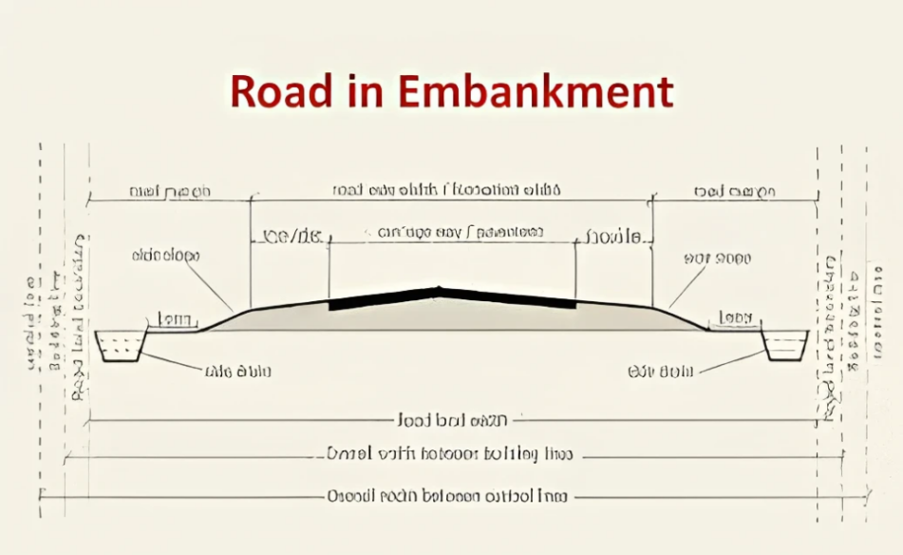

Cross section of road in cutting

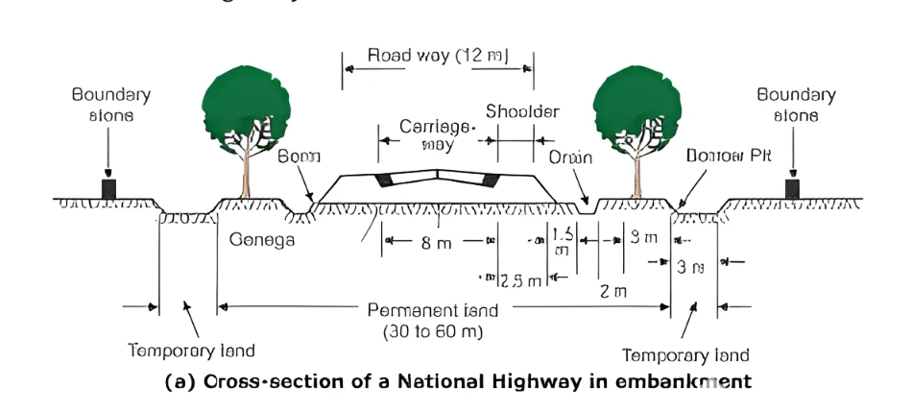

(c) Cross section of two lane national highway

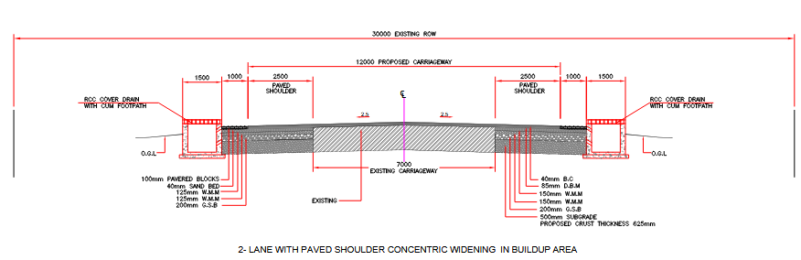

1.3.3.2 (d) Cross sections of two lane road in built-up area

The carriage way intended for one line of traffic movement may be called a traffic lane. The pavement maybe of single lane, Two lane or multilane.

ROAD CAMBER:
Camber is the cross slope provided across the road to raise middle of the road surface to drain off rain water from road surface. The camber given is either a parabolic, elliptic or straight line shape in the cross section.
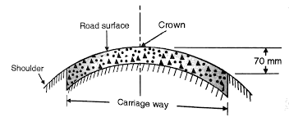

    - Camber or cross fall of road surface The objectives of providing camber are
- Surface protection of roads especially for grave land bituminous roads
- Sub-grade protection by proper drainage
- Quick drying of pavement which in turn increases safety.
Camber is measured in 1 in n or n % (eg. In 1 in 50 or 2%) and the value depends on the type of the pavement and the amount of rainfall.

Table: 1.3.4 IRC Values for camber

Surface type | Heavy rain | Light rain
Concrete/Bituminous | 2 % | 1.7 %
Gravel/WBM | 3 % | 2.5 %
Earthen | 4 % | 3.0 %

KERB

Kerb stones are a must for landscaping and infrastructural development. They establish defined limits, prevent vehicles from driving onto sidewalks, and provide structural support to pathways and roads. The Indian market has seen increased demand for kerb stones because of their durability and versatility. The choice of the correct size and type of kerb stone is integral to any project, whether it is a residential driveway or commercial road building.
As leading kerb stone manufacturers, along with expertise in manhole cover manufacturers, gully grating, and paver blocks, we aim to provide a complete guide on the standard sizes of kerb stones in India.
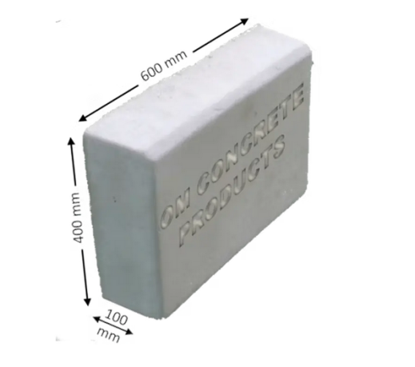
This guide will assist you in taking an informed decision for your next landscaping or infrastructure project

2.2 Design and average running speed, stopping and passing
- The minimum distance visible to a driver ahead to safety stop a vehicle travelling at design speed without collision with any other obstruction is termed as “SSD”. It is also termed as “Absolute Minimum Sight Distance” or ” Non-Passing Sight Passing”.
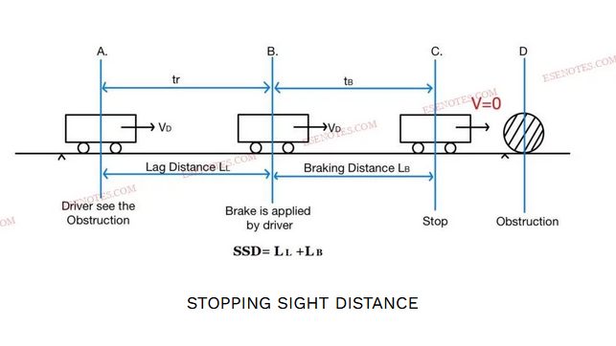
STOPPING SIGHT DISTANCE
The stopping distance of vehicle include:
- Lag Distance (LL)
- Braking Distance(LB)

(I). Lag Distance (LL)
- The distance travelled by vehicle at uniform design speed during the total reaction time (tr) termed as “Lag Distance (LL).
LL=V×tr . | V= Design Speed(m/sec).  tr= Reaction time(sec).  LL= Lag Distance(m).
LL=V×10360×60×tr.  LL=1033600V×tr.  LL=518V×tr.  LL=0.278×V×tr. | V (km/hours).  tr (sec).  tr = 2-4 (sec).
As per IRC reaction time is taken to be 2.5 second for SSD.

(II). Braking Distance(LB)
- The distance travelled by the vehicle after the application of brake, termed as Braking Distance(LB).
SSD BRAKING DISTANCE
Case-1: Ascending Gradient:→
Gradient= tanθ= s100= s%
Total Resisting Force= mg·sinθ+ F
F= Friction Force
F= Normal Force×Friction Coefficient.
F= f×mg·cosθ
Total Resisting Force= mg·sinθ+f×mg·cosθ
Equating the kinetic energy of vehicle and work done to stop it.
ΔK·E= Work Done (Work Done= Force× Distance)
0-12mV²= –LB(mg·sinθ+f×mg·cosθ)
if θ is very small
sinθ≈ tanθ
cosθ≈ 1
12V²= LB⋅g(tanθ+f·1)
 | tanθ≈ s%
12V²= LB⋅g(s%+ f)
LB=V22g(f+s%) | Here:  LB in meter.  V in metre/second.  g in metre/second².
Unit change  LB=(518V)22×9.81(f+s%)  LB=V2254.27(f+s%)  LB=V2254(f+s%) | Here:  LB in meter.  V in kilometre/hours.  g in metre/second².
Case-2: Decending Gradient:→
LB=V2254(f−s%)
Case-3: Flat Road:→
LB=V2254×f | s=0
SSD=LL+LB
SSD=0.278×V×tr+ V2254(f±s%)
SSD= Stopping Sight Distance (meter)
V= Design Speed(m/sec)
tr= Reaction time(sec)
f= Friction Coefficient(unit less)
s= Gradient
Note:
- SSD must be available at each & every section of the road.
- As the SSD, required on descending gradient is higher, it is necessary to determine the critical value of SSD for the descending gradient on the roads with gradient & for two way traffic flow.
- On the restricted width or on single lane roads when two way movement of traffic is permitted, the minimum SSD equal to twice the SSD to enable both the vehicle coming from opposite side to stop.(For single lane road,two way traffic)
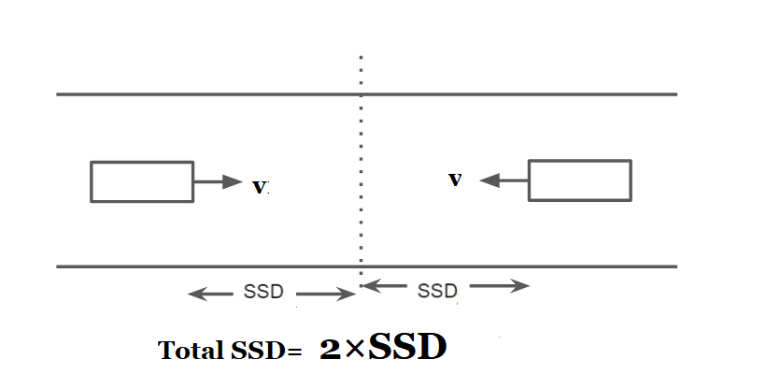SSD ON SINGLE LANE
- If SSD can not be provided on any stretch of road due to unavoidable reason for the design speed available, the speed should be restricted either by installing speed- limit regulation signs or by forced reduction of the speed.
- This is however temporary, and efforts must be made to provide SSD over the period of time. (By the changing alignment of road or by removing the obstruction.)
- The SSD recommended by IRC are as follows:
SSD WITH SPEED

3.3 SUPER ELEVATION
In order to counter act the effect of centrifugal force and to reduce the tendency of the vehicle to overturn or skid, the outer edge of the pavement is raised with respect to inner edge, by providing a transverse slope throughout the length of the horizontal curve. This transverse inclination to the pavement surface is known as super elevation or cant or banking. The super elevation ―e‖ is expressed as the ratio of the height of outer edge with respect to the horizontal width.
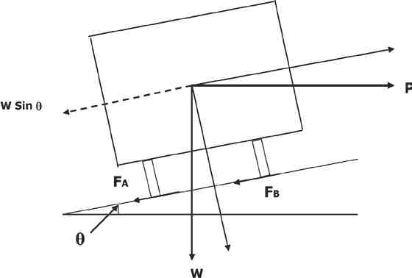

Super elevation is provided to counteract centrifugal force on moving vehiclesat horizontal curves and it is calculated from the following formula:
2
e = v / 225 R
where, e = super elevation (%) v = speed in km/hr
R = radius of curve in meters
Super elevation obtained from the above expression should, however be kept within limit mentioned below:

Plain terrain | - | 7 %
Snow bound area | - | 7 %
Hilly area but not snow bound | - | 10 %

SIGHT DISTANCE
The safe and efficient operation of vehicles on the road depends very much on the visibility of the road ahead of the driver. Thus the geometric design of the road should be done such that any obstruction on the road length could be visible to the driver from some safe distance ahead so that the driver can stop the vehicle before the obstruction. This distance is said to be the sight distance.

TYPES OF SIGHT DISTANCE
Sight distance available from a point is the actual distance along the road surface, over which a driver from a specified height above the carriage way has visibility of stationary or moving objects. Three sight distance situations are considered for design:

STOPPING SIGHT DISTANCE (SSD) OR THE ABSOLUTE MINIMUM SIGHT DISTANCE
Stopping sight distance (SSD) is the minimum sight distance available on a highway at any spot having sufficient length to enable the driver to stop a vehicle traveling at design speed, safely without collision with any other obstruction.

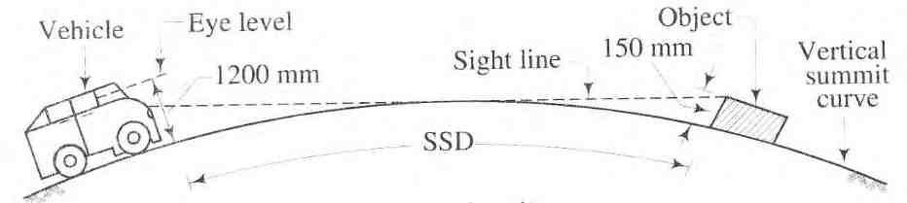

1.3.6.1.1 Stopping Sight Distance

INTERMEDIATE SIGHT DISTANCE (ISD)
It is defined as twice SSD

OVERTAKING SIGHT DISTANCE (OSD) FOR SAFE OVERTAKING OPERATION
The overtaking sight distance is the minimum distance open to the vision of the driver of a vehicle intending to overtake the slow vehicle ahead safely against the traffic in the opposite direction. The overtaking sight distance or passing sight distance is measured along the center line of the road over which a driver with his eye level 1.2 m above the road surface can see the top of an object 1.2 m above the road surface.

HEAD LIGHT SIGHT DISTANCE
It is the distance visible to a driver during night driving under the illumination of head
lights.

SAFE SIGHT DISTANCE TO ENTER INTO AN INTERSECTION.
The most important consideration in all these is that at all times the driver traveling at the design speed of the highway must have sufficient carriageway distance within his line of vision to allow him to stop his vehicle before colliding with a slowly moving or stationary object appearing suddenly in his own traffic lane.
The computation of sight distance depends on:
          - Reaction time of the driver
          - Speed of the vehicle
          - Efficiency of brakes
          - Frictional resistance between the tyre and the road
          - Gradient of the road.

ROAD GRADIENT
Gradient is the rate of rise or fall along the length of the road with respect to the horizontal. While aligning a highway, the gradient is decided for designing the vertical curve. Before finalizing the gradients, the construction cost, vehicular operation cost and the practical problems in the site has to be considered. Usually steep gradients are avoided as far as possible because of the difficulty in climbing which also increase the construction cost. More about gradients are discussed below.

EFFECT OF GRADIENT:
The effect of long steep gradient on the vehicular speed is considerable. This is particularly important in roads where the proportion of heavy vehicles is significant. Due to restrictive sight distance at uphill gradients the speed of traffic is often controlled by these heavy vehicles. As a result, not only the operating costs of the vehicles are increased, but also capacity of the roads will have to be reduced. Further, due to high differential speed between heavy and light vehicles, and between uphill and downhill gradients, accidents abound in gradients.
Ruling gradient, limiting gradient, exceptional gradient and minimum gradient are some types of gradients.
The ruling gradient or the design gradient is the maximum gradient with which the designer attempts to design the vertical profile of the road. This depends on the terrain, length of the grade, speed, pulling power of the vehicle and the presence of the horizontal curve.
This gradient is adopted when the ruling gradient results in enormous increase in cost of construction. On rolling terrain and hilly terrain it may be frequently necessary to adopt limiting gradient. But the length of the limiting gradient stretches should be limited and must be sandwiched by either straight roads or easier grades.
Exceptional gradient are very steeper gradients given at unavoidable situations. They should be limited for short stretches not exceeding about 100 metres at a stretch. In mountainous and steep terrain, successive exceptional gradients must be separated by a minimum 100 metre length gentler gradient. At hairpin bends, the gradient is restricted to 2.5%.

IRC Specifications of different gradients for different roads are as follows.
Table: 1.3.7.1 Gradients for different Terrains

Terrain | Ruling | Limiting | Exceptional
Plain/Rolling | 3.3 | 5.0 | 6.7
Hilly | 5.0 | 6.0 | 7.0
Steep | 6.0 | 7.0 | 8.0

ROAD CURVES
When two straight stretches of the road intersect at a point, a smooth curve is introduced connecting the straight stretches to facilitate easy, comfortable, and speedy and safety passage.
There are two types of curve based on the position of the curve in the highways. They are
- Horizontal curves
- Vertical curves

HORIZONTAL CURVES
A horizontal highway curve is a curve in plan (horizontally situated) to provide change in direction to the central line of road. When a vehicle traverses a horizontal curve, the centrifugal force acts horizontally outwards through the centre of gravity of the vehicle.
The centrifugal force development depends on the radius of the horizontal curve and the speed of the vehicle negotiating the curve. This centrifugal force is counteracted by the transverse frictional resistance developed between the tyres and the pavement which enables the vehicle to change the direction along the curve smoothly with greater stability of the vehicle.
The centrifugal force acting on a vehicle negotiating a horizontal curve has two effects:
(i) Tendency to over turn the vehicle about the outer wheel and (ii) Tendency to skid the vehicle laterally.

MINIMUM RADIUS OF HORIZONTAL CURVES:

A horizontal curve consists of a circular portion raised on the outer edge. Various design elements of a horizontal curve include radius (R), super elevation (e), transition curve, widening and sight distance. For the various design speeds, suggested values of R and e are so selected that both fall within the prescribed limits as given.
(i) Minimum radius of horizontal curve can be determined from the formula :

R = v2
127 (e + f)

where v = speed in km/hr R = radius in meters
e = super elevation (%)
f = coefficient of side friction (= 0.15 as per IRC).

Table: 1.3.8.2 Minimum Radii of Horizontal Curves as per IRC

Road Category | Plain Terrain |  | Rolling Terrain |  | Mountainous Terrain |  |  |  | Steep Terrain
Road Category |  |  |  |  | Areas not affected by snow |  | Areas affected by snow |  | Areas not affected by snow |  | Areas affected by snow
Road Category | Ruling Minimum | Absolute Minimum | Ruling Minimum | Absolute Minimum | Ruling Minimum | Absolute Minimum | Ruling Minimum | Absolute Minimum | Ruling Minimum | Absolute Minimum | Ruling Minimum | Absolute Minimum
Rural Roads (OD  and VR) | 90 | 60 | 60 | 45 | 20 | 14 | 23 | 15 | 20 | 14 | 23 | 15

A transition curve has a radius which decreases from infinity at the tangent point to a designed radius of the circular curve .

WIDENING OF PAVEMENT AT HORIZONTAL CURVES:
At sharp horizontal curve, it is necessary to widen the carriageway to facilitate safe passage of vehicles. The extra width to be provided to horizontal curve is given in Table 1.3.8.3 The widening should be effected by increasing the width at an approximately uniform rate along the transition curve. The extra width should be continued over the full length of the circular curve.

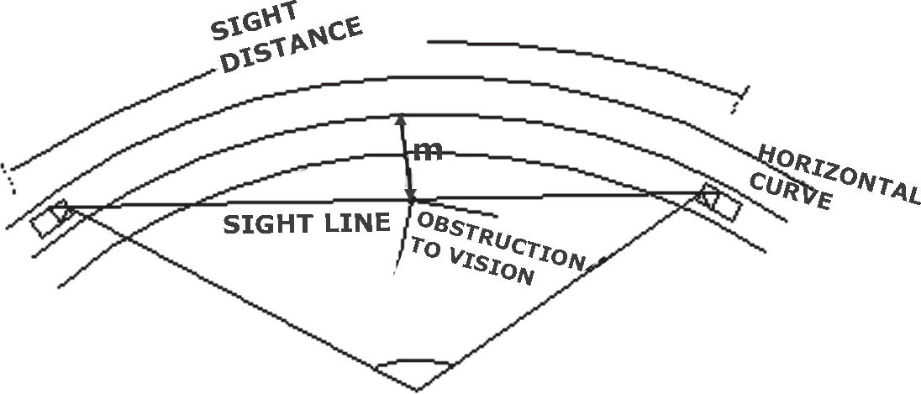
The widening should be done on both sides of the carriageway, except that on hill roads it will be preferable if the entire widening is done only on the inner side of the curve. Similarly, the widening should be provided only on the inside when the curve is plain circular and has no transition.
On curves in Plain and Rolling Terrain, having no transition (i.e Curve radius (Rc), widening should be achieved in the same way as the superelevation i.e. two-third being attained on the straight section before start of the curve and one-third on the curve.

Table : 1.3.8.3 Widening of Pavement at Curve (IRC SP : 20 - 2002, Page No. 39)

Radius of Curve (m) | Upto 20 | 21-60 | Above 60
Extra Widening for 3.75 m Wide Single  Lane Carriageway. (m) | 0.9 | 0.6 | Nil

SET BACK DISTANCE (M) AT HORIZONTAL CURVES
The clearance distance required from the centre line of a horizontal curve to an obstruction on the inner side of the curve to provide adequate sight distance is known as set back distance. It depends upon the following factors:
- Required sight distance, S
- Radius of horizontal curve, R
- Length of the curve, Lc which may be greater than S

.3.8.4 Set-back Distance at Horizontal Curves
Table: 1.3.8.4 IRC Recommended Setback Distance for single lane carriageway

Radius of circular curve (m) | Set- back distance (m)
Radius of circular curve (m) | S=20m  (v=20 kph) | S=25m  (v=25kmph) | S=30m  (v=30kmph) | S=45m  (v=40kmph) | S=60m  (v=50kmph)
14 | 3.4 | - | - | - | -
15 | 3.2 | - | - | - | -
20 | 2.4 | 3.8 | - | - | -
23 | 2.1 | 3.3 | - | - | -
30 | 1.7 | 2.6 | 3.7 | - | -
33 | 1.5 | 2.3 | 3.4 | -
50 | 1.0 | 1.6 | 2.2 | 5.0 | -
60 | - | 1.3 | 1.9 | 4.2 | -
80 | - | 1.0 | 1.4 | 3.1 | 5.6
100 | - | 0.8 | 1.1 | 2.5 | 4.5
120 | - | 0.7 | 0.9 | 2.1 | 3.7
150 | - | 0.5 | 0.5 | 1.7 | 2.3

VERTICAL CURVES

Vertical curves are introduced for smooth transition at grade changes. The vertical curves may be classified into two categories. 1. Summit curves or crest curves with convexity upwards. 2. Valley or sag curves with concavity upwards.
Both summit curves and valley curves should be designed as parabola, the length of the vertical curves is controlled by sight distance requirements, but curves with greater lengths are aesthetically better. Curves should be provided at all grade changes exceeding those given in below.
Table : 1.3.8.5 Minimum length of Vertical curve (IRC SP : 20 - 2002, Page No. 42)

Design speed | Maximum grade  change (%) not requiring a vertical | Minimum length of vertical curve in (m)
Upto 35 | 1.5 | 15
40 | 1.2 | 20
50 | 1.0 | 30

SUMMIT CURVE
The length of summit curve is governed by the choice of sight distance according to the operating condition of road. The required length may be calculated from the formulae given in Table.
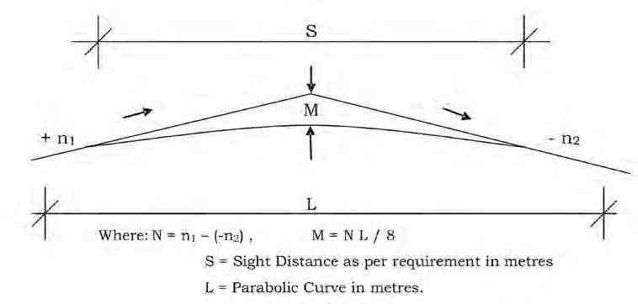

Case | For stopping sight | For intermediate sight distance / overtaking sight
L > S | L=NS²/4.4 | L= NS²/9.6
L< S | L= 2S-(4.4)/N | L= 2S-(9.6)/N

L = Length of parabolic vertical curve in metres. S = Sight Distance in metres.
1.3.8.6 Summit Curve
Table: 1.3.8.6 Length of summit curve (IRC SP : 23 - 1993)
Where
N = deviation angle, i.e. the algebraic difference between the two grades.
Note : 1. For summit curves, overtaking sight distance should be the general criterion. Where it is not feasible, intermediate sight distance should be adopted as the next best. Safe stopping sight distance is the absolute minimum.
2. For valley curves, safe stopping sight distance should be adopted.

VALLEY CURVE :
The length of valley transition curve is designed based on the two criteria
- The allowable rate of change of centrifugal acceleration of 0.6 m/sec³ and
- The head light sight distance, and the higher of the two values may be adopted. Usuallythesecondcriterion of headlightsightdistance is higher and therefore governs the design.
- The length of valley transition curve according to first criteria i.e. for comfort condition is given by

L = 0.38 (NVS)½
- The length of valley curve according to the second criteria may be calculated by using the formulae given in below.

Table: 1.3.8.7.1 Length of Valley Curve (IRC SP : 23 - 1993, Page No. 21)

Case | Length of valley curve
L > S | L = NS²/(1.5+0.035 S)
L < S | L = 2S-(1.5+0.035 S)/N

Where

N = deviation angle, i.e. the algebraic difference between the two grades L = Length of parabolic vertical curve in metres
S = sight distance requirements in metres.

Soil is used for the construction of the bottom most layer of the pavement, i.e. sub-grade.Subgrade:-

1.sub-grade is the layer of the pavement whose main function is to support the upper layers
of the pavement and to provide the good drainage facility to the infiltrating rain water. It has
to act as a single structure along with other layers of the pavement.

2. Soil is compacted to its maximum dry density which can be achieved by using the optimum
moisture content and the methods of compaction control. Strength has to be ensured which
is required for the given design thickness of the pavement.

CBR TEST:-

NEED AND SCOPE
The california bearing ratio test is penetration test meant for the evaluation of subgrade
strength of roads and pavements.
Equipments and tool required.

1. Cylindrical mould
2. Spacer disc
3. Metal rammer
4. Weights
5. Loading machine
6. Metal penetration piston
7. Two dial gauges
8. Sieves. 4.75 mm and 20 mm
9. Miscellaneous apparatus, such as a mixing bowl, straight edge, scales soaking tank or
pan, drying oven, filter paper and containers.
C.B.R. = Test load/Standard load × 100
It is tested by two ways
1. Prepare specimen
2. Penetrating

Prepare specimen:-

First place the mould and place the sample on it by 3layer each layer temped by 25 blows.
Then wt.this specimen with mould and record th data.

Procedure:-

- • Place the mould assembly with the surcharge weights on the penetration test
machine.
- • Seat the penetration piston at the center of the specimen with the smallest possible
load, but in no case in excess of 4 kg so that full contact of the piston on the sample
is established.
- • Set the stress and strain dial gauge to read zero. Apply the load on the piston so that
the penetration rate is about 1.25 mm/min.
- • Record the load readings at penetrations of 0.5, 1.0, 1.5, 2.0, 2.5, 3.0, 4.0, 5.0, 7.5,
10 and 12.5 mm. Note the maximum load and corresponding penetration if it occurs
for a penetration less than 12.5 mm.

CBR= unit load carried by specimen at standard penetrations/unit load carried by standard
crushed stone at standard penetration×100

Procedure for Los Angeles Abrasion Test:

- • The aggregates sample consists of clean aggregates dried in an oven at 105° –
110°C. The aggregates sample should conform to any of the grading shown in the
below table.

- • Select the size of aggregate to be used in the test such that it conforms to the

grading to be used in construction, to the maximum extent possible
.
- • Place the aggregates and abrasive charge balls on the cylinder and fix the cover.

- • After that Rotate the machine at a speed of 30 to 33 revolutions per minute. The
number of revolutions should be 500.

- • The machine is stopped after the specified number of revolutions and the aggregate
sample is discharged to a tray.

- • The entire stone dust made from a machine is sieved on 1.70 mm IS sieve.

- • The material size more than 1.7 mm size is weighed correct to one gram

Observations:

The original weight of aggregate sample = W1 g
The weight of aggregate sample retained = W2 g
Weight sample passing 1.7mm IS sieve = W1 – W2 g
Abrasion Value = (W1 – W2 ) / W1 X 100

Impact test of aggregate :-

To observe toughness

Procedure

- • The test sample consists of aggregates sized 10.0 mm 12.5 mm. Aggregates may be
dried by heating at 100-110° C for a period of 4 hours and cooled.

- • Sieve the material through 12.5 mm and 10.0mm IS sieves. The aggregates passing
through 12.5mm sieve and retained on 10.0mm sieve comprises the test material.

- • Pour the aggregates to fill about just 1/3 rd depth of measuring cylinder
.
- • Compact the material by giving 25 gentle blows with the rounded end of the tamping rod.

- • Add two more layers in similar manner, so that cylinder is full.
• Strike off the surplus aggregates.

- • Determine the net weight of the aggregates to the nearest gram(W).

- • Bring the impact machine to rest without wedging or packing up on the level plate,
block or floor, so that it is rigid and the hammer guide columns are vertical.

- • Fix the cup firmly in position on the base of machine and place whole of the test

- sample in it and compact by giving 25 gentle strokes with tamping rod.

- • Raise the hammer until its lower face is 380 mm above the surface of aggregate.

- sample in the cup and allow it to fall freely on the aggregate sample.

- • Remove the crushed aggregate from the cup and sieve it through 2.36 mm IS sieves
until no further significant amount passes in one minute. Weigh the fraction passing
the sieve to an accuracy of 1 gm.

Observations:-

Total weight of dry sample (W1 gm)
Weight of portion passing 2.36 mm sieve (W2 gm)
Aggregate Impact Value (percent) = W2 / W1 X 100
Crushing strength of aggregate
objective :- used for strength of aggregate

Apparatus Required:-

1.steel cylinder
2.Tamping rod
3.balance of capacity
4.IS sieves of sizes 12.5mm, 10mm and 2.36mm
5. compression testing machine.
6.Dial gauge

Procedure of Aggregate Crushing Value Test:

- • Put the cylinder in position on the base plate and weigh it (W).

- • Put the sample in 3 layers, each layer being subjected to 25 strokes using the
tamping rod. Care being taken in the case of weak materials not to break the
particles and weigh it (W1).

- Level the surface of aggregate carefully and insert the plunger so that it rests
horizontally on the surface. Care being taken to ensure that the plunger does not jam
in the cylinder.

- • Place the cylinder with plunger on the loading platform of the compression testing
machine.

- • Apply load at a uniform rate so that a total load of 40T is applied in 10 minutes.

- • Release the load and remove the material from the cylinder.

- • Sieve the material with 2.36mm IS sieve, care being taken to avoid loss of fines.

- • Weigh the fraction passing through the IS sieve (W2).

Aggregate crushing value = (W2 x 100) / (W1-W)
W2 =Weight of fraction passing through the appropriate sieve
W1-W =Weight of surface dry sample.

Water absorption test

Apparatus

1.Wire Mesh Bucket
2.Setup of Water Absorption Test
Procedure:-
• About 2 kg of aggregate sample is taken, washed to remove fines and then placed in
the wire basket. The wire basket is then immersed in water, which is at a temperature
of 220C to 320C..
• After immersion the entrapped air is removed from the sample by lifting the basket 25
mm above the base of the tank and allowing it to drop, 25 times at a rate of about
one drop per second.
• The basket, with aggregate are kept completely immersed in water for a period of 24
± 0.5 hour.
• The basket and aggregate are weighed while suspended in water, which is at a
temperature of 220C to 320C.5.
• The basket and aggregates are removed from water and dried with dry absorbent
cloth.
• The surface dried aggregates are also weighed.
Calculation
Weight of saturated aggregates in air: W1 g
Weight of oven dry aggregates in air: W2 g
Water Absorption (%)= [(W1-W2)*100]/W2

Soundness test of aggregate
Chemical
Sodium Sulphate Solution
Magnesium Sulphate Solution
PREPARATION OF TEST SAMPLE FOR FINE AGGREGATE
• Wet sieve the sample through a nest of IS sieves, the lower being 300 micron and
the upper being 10 mm size.
• material passing 10 mm sieve and retained on 300 micron sieve is then dried and
taken for the test.
• sample collected as above is again sieved through a series of sieves such as 10
mm, 4.75 mm, 2.36 mm, 1.18 mm, 600 micron and 300 micron.
• 100 g of sample from each of the separated fraction and place it in separate
containers for the test.
TEST SAMPLE FOR COARSE AGGREGATE
• Wash the coarse aggregate through 4.75 mm IS sieve and dry the material retained
on the sieve in an oven maintained at a temp of 105 to 1100C, till it attains a constant
mass.
• the dried sample to separate it into different size fractions using sieves of sizes 80
mm, 63 mm, 40 mm, 20 mm, 10 mm, 4.75 mm.
Procedure:-
• Take individual samples in a wire mesh basket and immerse it in the solution of
sodium sulphate or magnesium sulphate for not less than 16 hours nor more than 18
hours, in such a manner that the solution covers them to a depth of at least 15 mm.
• After completion of the immersion period, remove the samples from solution and
allow it to drain for 15 minutes and place it in drying oven.
• Dry the sample until it attains a constant mass and then remove it from oven and cool
it to room temperature.
• The process of alternate immersion and drying is repeated until the specified number
of cycles as agreed between the purchaser and the vendor is obtained.
• After completion of the final cycle and after the sample has been cooled, wash it to
free from sodium sulphate or magnesium sulphate solution.
• Then dry each fraction of the sample to constant temp of 105 to 1100C and weigh it.

UNIT-III

CHAPTER-3

CONSTRUCTION OF ROAD PAVEMENTS
    - OBJECTIVES
A highway pavement is a structure consisting of superimposed layers of processed materials above the natural soil known as ‗sub-grade‘. The pavement‘s primary function is to distribute the applied vehicle loads to the sub-grade. The pavement structure should be able to provide a surface of acceptable riding quality, adequate skid resistance, favourable light reflecting characteristics and low noise pollution. The ultimate aim is to ensure that the transmitted stresses due to the vehicle load are sufficiently reduced, so that they will not exceed bearing capacity of the sub- grade. Two types of pavements are generally recognized as serving this purpose, namely flexible pavements and rigid pavements. Improper design of pavements leads to early failure of pavements affecting the riding quality.

REQUIREMENTS OF AN IDEAL PAVEMENT

An ideal pavement should meet the following requirements:
- Sufficient width and thickness to distribute the wheel load stresses to a safe value on the sub-grade soil
- Structurally strong to withstand all types of stresses imposed upon i
- Adequate coefficient of friction to prevent skidding of vehicles
- Smooth surface to provide comfort to road users even at high speed
- Produce least noise from moving vehicles
- Dust proof surface so that traffic safety is not impaired by reducing visibility
- Impervious surface, so that sub-grade soil is well protected
- Long life with low maintenance cost.

TYPES OF PAVEMENTS:
The pavements can be classified based on the structural performance into two, flexible pavements and rigid pavements. In flexible pavements, wheel loads are transferred by grain-to- grain contact of the aggregate through the granular structure. The flexible pavement, having less flexural strength, acts like a flexible sheet (e.g. bituminous road). On the contrary, in rigid pavements, wheel loads are transferred to sub-grade soil by flexural strength of the pavement and the pavement acts like a rigid plate (e.g. Cement concrete roads). In addition to these, composite pavements are also available. A thin layer of flexible pavement over rigid pavement is
an ideal pavement with most desirable characteristics. However, such pavements are rarely used in new construction because of high cost and complex analysis requirement.

Wheel Load P
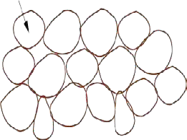
Granular Structure

1.2.3 Load transfer in granular structure

FLEXIBLE PAVEMENTS AND RIGID PAVEMENTS
      - FLEXIBLE PAVEMENT
Flexible pavements will transmit wheel load stresses to the lower layers by grain-to-grain transfer through the points of contact in the granular structure (see Figure). The wheel load acting on the pavement will be distributed to a wider area, and the stress decreases with the depth. Taking advantage of this stress distribution characteristic, flexible pavements normally has many layers. Hence, the design of flexible pavement uses the concept of layered system. Based on this, flexible pavement may be constructed in a number of layers and the top layer has to be of best quality to sustain maximum compressive stress, in addition to wear and tear. The lower layers will experience lesser magnitude of stress and low quality material can be used. Flexible pavements are constructed using bituminous materials. These can be either in the form of surface treatments (such as bituminous surface treatments generally found on low volume roads) or, asphalt concrete surface courses (generally used on high volume roads such as national

highways). Flexible pavement layers reflect the deformation of the lower layers on to the surface layer (e.g., if there is any undulation in sub-grade then it will be transferred to the surface layer). In the case of flexible pavement, the design is based on overall performance of flexible pavement, and the stresses produced should be kept well below the allowable stresses of each pavement layer.
Pavement structure consists of the prepared subgrade and the pavement component layers such as sub-base, base and surface course. The stability or the structural capacity of the pavement depends upon the pavement layer system including the subgrade. However, the road users are concerned about the riding quality, safety and other performance aspects of the road pavement rather than the pavement structure, design life etc. Hence, it is important to ensure the above requirements also while designing a pavement. The flexible pavements are constructed as a multi-layer system consisting of typical component layers, namely sub-base, base course, and surface course.
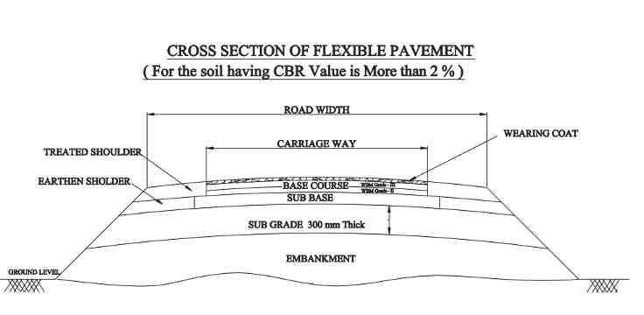

1.2.4.1 Flexible pavements consist of a number of layers.

RIGID PAVEMENTS:
Rigid pavements have sufficient flexural strength to transmit the wheel load stresses to a wider area below. A typical cross section of the rigid pavement is shown in Figure. Compared to flexible pavement, rigid pavements are placed either directly on the prepared sub-grade or on a single layer of granular or stabilized material. Since there is only one layer of material between the concrete and the sub-grade, this layer can be called as base or sub-base course.

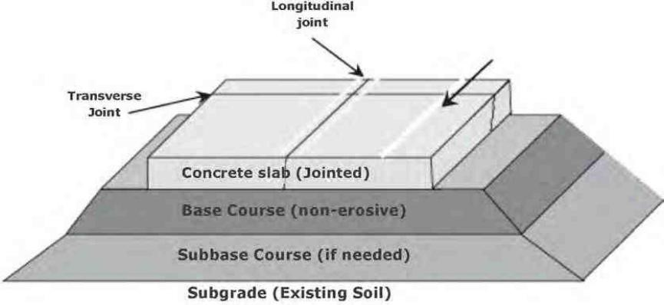

1.2.4.2. RIGID PAVEMENT
In rigid pavement, load is distributed by the slab action, and the pavement behaves like an elastic plate resting on a viscous medium. Rigid pavements are constructed by Portland cement concrete (PCC) and should be analyzed by plate theory instead of layer theory, assuming an elastic plate resting on viscous foundation. Plate theory is a simplified version of layer theory that assumes the concrete slab as a medium thick plate which is plane before loading and to remain plane after loading. Bending of the slab due to wheel load and temperature variation and the resulting tensile and flexural stress.

COMPARISON OF FLEXIBLE AND RIGID PAVEMENT

Flexible Pavements | Rigid Pavements
Deformation in the sub-grade is  transferred to the upper layers | Deformation in the subgrade is not  transferred to subsequent layers
Design is based on load distributing  characteristics of the component layers | Design is based on flexural strength or  slab action
Have low flexural strength | Have high flexural strength
Load is transferred by grain to grain | No such phenomenon of grain to grain

contact | load transfer exists
Have low construction cost but repairing  cost is high | Have low repairing cost but construction  cost is high
Have low life span (High Maintenance  Cost) | Life span is more as compare to flexible  (Low Maintenance Cost)
Surfacing cannot be laid directly on the  sub grade but a sub base is needed | Surfacing can be directly laid on the sub  grade
No thermal stresses are induced as the pavement have the ability to contract and  expand freely | Thermal stresses are more vulnerable to be induced as the ability to contract and  expand is very less in concrete
Expansion joints are not needed | Expansion joints are needed
Strength of the road is highly dependent  on the strength of the sub grade | Strength of the road is less dependent on  the strength of the sub grade
Rolling of the surfacing is needed | Rolling of the surfacing in not needed
Road can be used for traffic within 24  hours | Road cannot be used until 14 days of  curing
Force of friction is less Deformation in the sub grade is not transferred to the upper layers. | Force of friction is high
Damaged by Oils and Certain Chemicals | No Damage by Oils and Greases

OTHER TYPES OF PAVEMENTS :
The following types of pavements are based on the material used in the road consruction.
- Cement concrete pavement
- PSC pavement
- WBM pavement
- Bituminous pavement

FACTORS AFFECTING DESIGN OF PAVEMENT
There are many factors that affect pavement design which can be classified into four categories as traffic and loading, structural models, material characterization, environment.
- Volume of Traffic and intensity of vehicular loading
- Contact area and contact pressure between wheel and pavement surface
- Axle configuration such as single axle, multiple axle etc.,
- Nature of moving loads of vehicle: ( Fast moving/slow moving) Faster the moving the stress will be more and vice versa.
- Repetition of loads: The influence of traffic on pavement not only depending upon the magnitude of the wheel load and also on the frequency of the load application.
- Nature of structural model of pavement
- Quality of material used in the construction
- Weathering conditions such as temperature, rainfall and other environmental factors in the stretch of the road

1.3.8.7.2 Length of Valley Curve
TRAFFIC ENGINEERING
    - OBJECTIVES OF TRAFFIC ENGINEERING:
The main objectives of traffic engineering are listed below
- To have a safe, convenient, rapid and economic transport of persons and goods.
- To achieve smooth and easy flow of traffic at intersections
- To improve the riding comfort and speed of vehicles
- To make the roads safe for the movement of pedestrians and vehicles
- To remove traffic congestion and reduce delay in road journeys.
- To provide vital data about the condition of existing traffic for improvement for future requirements.

TRAFFIC SURVEY:
The types of traffic surveys are usually carried out are grouped as follows
- Origin and destination Survey
- Traffic Volume Survey
- Spot Speed survey
- Accident Survey
- Speed and delay survey
- Parking Survey

PURPOSE OF TRAFFIC STUDIES:
The main purpose of traffic studies are
- To determine the facilities to be provided on road and suggest the measures to improve the traffic of the road
- To get suitable data for geometric design of various components of road
- To get information related to nature of traffic at present and to forecast its future trend
- To analyze the road accidents and to find out road elements contributing to their occurrence
- To initiate appropriate action to eliminate the condition contributing the accidents.
- To suggest measures to control speed of vehicles

ROAD ACCIDENTS:
Road accidents are undoubtedly the most serious eventuality due to defective traffic planning and controlling the traffic. Road accidents result in vital loss of human life and consequent
economic depreciation of a country especially the victim is a knowledgeable and skilled person. The reasons for this are the extremely dense chaotic road traffic and the relatively great freedom of movement given to drivers. Accidents involving heavy goods vehicles (especially coaches and lorries with trailers) occur all too frequently despite calls for responsible behaviour and respect for rules and regulation pertaining to the traffic., It is also due to irresponsible behaviour of drivers such as drunken driving and non-adherence of speed restriction at different zones and non adaptability of driving in adverse weather conditions (like rain, ice, fog, etc.). The prevention of road accidents is also extremely important and will be ensured by strict laws, by technical and police controls, ongoing training for drivers (especially those involved in the transport of dangerous and hazardous substances) and strict legal punishment to the erring drivers.

CAUSES OF ROAD ACCIDENTS:
- Non-licensed and inexperienced drivers.
- Driving by minors.
- Driving at high speed during night- time.
- Driving during cold waves, mist, fog, dust storms, and cyclonic storms.
- Driving in a state of drunkenness or under the influence of sedating drugs.
- Eagerness to fulfill work schedules.
- Defective and old vehicles.
- Poor maintenance of vehicles.
- Night blindness of drivers.
- Passing through narrow and congested roads in high speed.
- Driving when red light is on and ignoring traffic signs.
- Driving without lights during heavy downpours.
- Poor or no street lighting.
- Inattentive pedestrians walking at the center of the road.
- Cyclists and cycle rickshaws without headlights during the night.
- Sudden appearance of stray cattle and side traffic. Accident victims are generally left unattended on the road especially pedestrians and cyclists till police arrive.
- Fraudulent means are used in getting driving licenses from the transport department. Such improper issue of driving licenses is responsible for causing accidents due to human error.

Drunken driving during the night is a major reason for accidents as drivers lose control.
- Lack of adequate road signs and information increases accidents on roads.
- Overtaking the moving vehicle without assessing the traffic condition ahead of the road.

PREVENTIVE MEASURES:
- The condition which leads to accident mentioned in the above paragraph (1.4.4) should be removed to have a safe transport on the highways.
- Obey traffic rules and initiate severe penal action on erring driver
- Insist wearing of seat belts of driver and other passengers in the vehicle.
- Preference is to be given to pedestrians and children crossing the road especially on zebra crossing.
- Erect road signs at appropriate places in predominant manner
- It is vital to install reflectors on roads so that deviations and medians are clearly visible to drivers.
- Establishment of road safety departments by governments to build capacity at national and local levels to monitor the magnitude, severity and burden of road traffic collisions and injuries.
- Setting up of safety standards for motor vehicles in consonance with international practice.
- Designing roads and highways with special attention to the needs of vulnerable road users and promotion of traffic calming techniques.
- Marking separate lanes for bicyclists

PARKING
Parking is one of the major problems that are created due to the increased vehicular road traffic. The availability of less space in urban areas has increased the demand for parking space, especially in areas like Central business district. The lack of adequate parking space for vehicle affects the economic activities adversely in urban areas.

METODS OF PARKING
      - ON STREET PARKING
On street parking means the vehicles are parked on the sides of the street itself. This will be usually controlled by government agencies itself. Common types of on-street parking are as listed below. This classification is based on the angle in which the vehicles are parked
with respect to the road alignment. As per IRC, the standard dimensions of a car is taken as 5× 2.5 metres and that for a truck is 3.75× 7.5 metres.

L
5.9
2.5

5.0
1.4.7.1 (a) Illustration of parallel parking

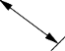

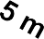

1.254.33 L 1.25 m
A B C D 30
E
O
1Q 2 P
....
n

4.66 m

1.4 .7 .1 ( b) Illustration of 30◦ parking

- Parallel parking: The vehicles are parked along the length of the road. Here there is no backward movement involved while parking or taking out the vehicle. Hence, it is the safest parking from the accident perspective. However, it consumes the maximum curb length and therefore only a minimum number of vehicles can be parked for a given kerb length. This method of parking produces least obstruction to the on-going traffic on the road since least road width is used. Parking and taking out the car from the parking is difficult in this Parallel parking.

- 30◦ parking: In thirty degree parking, the vehicles are parked at 30◦ with respect to the road alignment. In this case, more vehicles can be parked compared to parallel parking. Also there is better maneuverability. Delay caused to the traffic is also less in this type of parking.

45◦ parking: As the angle of parking increases, more number of vehicles can be parked. Hence compared to parallel parking and thirty degree parking, more number of vehicles can be accommodated in this type of parking.




5.31 m
1.77
45

1.4.7.1 (c) 45 Degree Parking
- 60◦ parking: The vehicles are parked at 60◦ to the direction of road. More number of vehicles can be accommodated in this parking type.
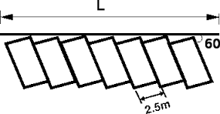

1.4.7.1 (d) 60 Degree Parking

- Right angle parking: In right angle parking or 90◦ parking, the vehicles are parked perpendicular to the direction of the road. Although it consumes more width of the road, but kerb length required is very little. In this type of parking, the vehicles need complex maneuvering and this may cause severe accidents. This arrangement causes obstruction to the road traffic particularly if the road width is
less. However, it can accommodate maximum number of vehicles for a given kerb length.

L

2.5

1.4.7.1 (e) Illustration of 90◦ parking

OFF STREET PARKING

In many urban centres, some areas are exclusively allotted for parking which will be at some distance away from the main stream of traffic. Such a parking is referred to as off- street parking. They may be operated by either public agencies or private firms. A typical layout of an off-street parking is shown in figure.

ENTRY

EXIT

1.4.7.2. Illustration of off-street parking

1.4.7.3. MULTIPLE LEVEL CAR PARKING
It is a building (or part there hereof) which is designed specifically to be for Automobile Parking and where there are a number of floors or levels on which parking takes place.
In order to accommodate the large volume of vehicles, small cities and towns must develop their infrastructure. One solution may be a multi-level car parking system to maximize car parking capacity by utilizing vertical space, rather than expand horizontally. With land in metros and ‗A‘ grade cities becoming scarce and dearer, and plots getting smaller, conventional parking is proving infeasible.

ROAD JUNCTION
1.4..8.1 TRAFFIC INTERSECTIONS
Intersection is an area shared by two or more roads. This area is designated for the vehicles to turn to different directions to reach their desired destinations. Its main function is to guide vehicles to their respective directions. Traffic intersections are complex locations on any highway. This is because vehicles moving in different direction want to occupy same space at the same time. In addition, the pedestrians also seek same space for crossing. Drivers have to make split second decision at an intersection by considering his route, intersection geometry, speed and direction of other vehicles etc. A small error in judgment can cause severe accidents. It also causes delay and it depends on type, geometry, and type of control. Overall traffic flow is controlled by road signal. It also affects the capacity of the road. Therefore, both from the accident perspective and the capacity perspective, the study of intersections is very important for the traffic engineers especially in the case of urban scenario.
The intersections are of two types. They are at-grade intersections and grade- separated intersections.

P P

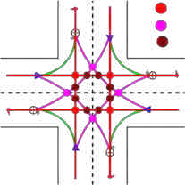

      - Conflicts at an intersection

AT-GRADE INTERSECTIONS:
In at-grade intersections, all roadways join or cross at the same vertical level. The essence of the intersection control is to resolve these conflicts at the intersection for the safe and efficient movement of both vehicular traffic and pedestrians. Two methods of intersection controls are there: time sharing and space sharing. The type of intersection control that has to be adopted depends on the traffic volume, road geometry, cost involved, importance of the road etc. The above sketch explains the negotiations of traffic moving in the different direction at an intersection.

CHANNELIZED INTERSECTION:

Vehicles approaching an at At-grade intersection are directed to definite paths by islands, marking etc. and this method of control is called channelization.
Channelized intersection provides more safety and efficiency. It reduces the number of possible conflicts by reducing the area of conflicts available in the carriageway. Channelization of traffic through a three-legged intersection and a four-legged intersection is shown in the figure 1.4.8.1 (a) and 1.4.8.1 (b) .

1.4.8.1 (a) Channelization of traffic through a three-legged intersection
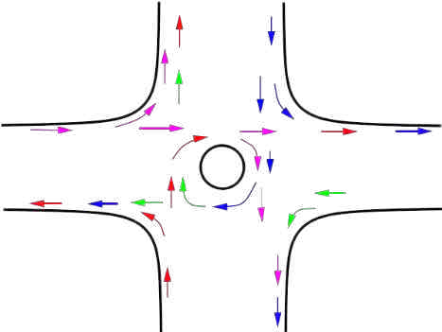

      - (b) Channelization of traffic through a four-legged intersection

GRADE SEPARATED INTERSECTION:

Grade separated intersections allows the traffic to cross at different vertical levels.
Sometimes the topography itself may be helpful in constructing such intersections. Otherwise, the initial construction cost required will be very high. Therefore, they are usually constructed on high speed facilities like expressways, freeways etc. This type of intersection increases the road capacity because vehicles can flow with high speed and accident potential is also reduced due to vertical separation of traffic.
Grade-separated intersections are provided to separate the traffic in the vertical grade. But the traffic need not be those pertaining to road only. When a railway line crosses a road, then also grade separators are used. Different types of grade-separators are flyovers and interchange. Flyovers itself are subdivided into overpass and underpass. When two roads cross at a point, if the road having major traffic is elevated to a higher grade for further movement of traffic, then such structures are called overpass. Otherwise, if the major road is depressed to a lower level to cross another by means of an under bridge or tunnel, it is called under-pass.
        - INTERCHANGE: Interchange is a system where traffic between two or more roadways flows at different levels in the grade separated junctions. Common types of interchange include trumpet interchange, diamond interchange, and cloverleaf interchange.
        - TRUMPET INTERCHANGE: Trumpet interchange is a popular form of three leg interchange. If one of the legs of the interchange meets a highway at some angle but does not cross it, then the interchange is called trumpet interchange. A typical layout of trumpet interchange is shown in figure.
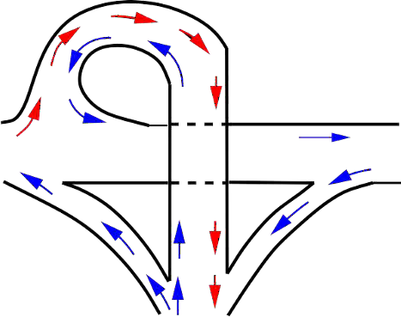

1.4.8.2. (a) Trumpet Interchange
        - Diamond interchange: Diamond interchange is a popular form of four-leg interchange found in the urban locations where major and minor roads crosses. The important feature of this interchange is that it can be designed even if the major road is relatively narrow. A typical layout of diamond interchange is shown in figure.


      - (iii) Diamond interchange

        - Clover leaf interchange: It is also a four leg interchange and is used when two highways of high volume and speed intersect each other with considerable turning movements. The main advantage of cloverleaf intersection is that it provides complete separation of traffic. In addition, high speed at intersections can be achieved. However, the disadvantage is that large area of land is required. Therefore, cloverleaf interchanges are provided mainly in rural areas. A typical layout of this type of interchange is shown in figure.

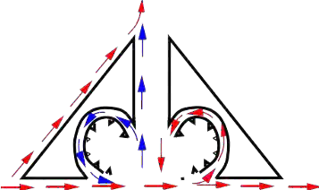
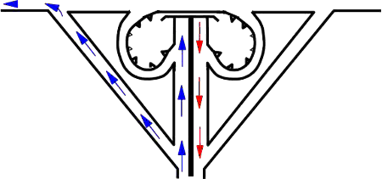

.4.8.2. (iv) Cloverleaf interchange

UNIT- IV
RAILWAY ENGINEERING
Chapter 4
INTRODUCTION
3.1.1 Introduction
The history of railways is closely linked with civilization of human beings. As the
necessity arose, human beings developed various methods of transporting goods from one place to another. In olden days goods were carried as head loads or in carts drawn by men or animals. Then efforts were made to replace animal power with mechanical power. In 1769, Nicholes Carnot, a Frenchman, carried out the pioneering work of developing steam energy. This work had very limited success and it was only in the year 1804 that Richard Trevithick designed and constructed a steam locomotive. This locomotive, however, could be used for traction on roads only. The credit of perfecting the design goes to George Stephenson, who in 1814 produced the first steam locomotive used for traction in railways. The first public railway in the world was opened to traffic on 27 September 1825 between Stockton and Darlington in the UK. Simultaneously, other countries in Europe also developed such railway systems; most introduced trains for carriage of passenger traffic during that time. The first railway in Germany was opened from Nurenberg to Furth in 1835. The USA opened its first railway line between Mohawk and Hudson in 1833.
The first railway line in India was opened in 1853. The first train, consisting of one steam engine and four coaches, made its maiden trip on 16 April 1853, when it traversed a 21-mile stretch between Bombay (now Mumbai) and Thane in 1.25 hours. Starting from this humble beginning, Indian Railways has grown today into a giant network consisting of 63,221 route km and connecting our country from the Himalayan foothills in the north to Cape Comorin (Kanyakumari) in the south and from Dibrugarh in the east to Dwarka in the west. Indian Railways has a glorious past of more than 150 years.
3.1.2 Development of Railways in India
In the year 1832 the first Railway running on steam engine, was launched in England.
Thereafter on 1st of August, 1849 the Great Indian Peninsular Railways Company was
established in India. On 17th of August 1849, a contract was signed between the Great Indian Peninsular Railways Company and East India Company. As a result of the contract an experiment was made by laying a railway track between Bombay and Thane (33.6 Kms).On 16th April, 1853, the first train service was started from Bombay to Thane.
• On 15th August, 1854, the 2nd train service commenced between Howrah and Hubli. • On the 1st July, 1856, the 3rd train service in India and first in South India
commenced between Vyasarpadi and Walajah Road and on the same day the section
between Vyasarpadi and Royapuram by Madras Railway Company was also opened.
Subsequently construction of this efficient transport system began simultaneously in different parts of the Country. By the end of 19th Century 24752 Kms. of rail track was laid for traffic. At this juncture the power, capital, revenue rested with the British private companies. Revenue started flowing through passenger as well as through goods traffic.
Between the years 1881 and 1897, eight more new private companies were
established to bring rapid development in railways. In the year 1905, Railway Board was established under the Commerce and Industries Department to look after the Indian Railways. During the World War I (1914 - 1921) some lines of strategic importance were constructed. The nationalisation of Indian Railways took place in the year 1922. Burma was separated from India with its share of 3,200 km length of railway line. During the World War II, 'War Transport Board' was formed and the railway lines were increased to meet the war requirements. After the Independence of India, most of the private railway companies were taken over by the Government of India. After the partition of India and Pakistan in the year 1947, the length of Indian Railways was reduced from 65,217 km to 54,149 km. Indian Railways is divided into several zones, which are further sub-divided into divisions. The number of zones in Indian Railways increased from six to eight in 1951.nine,in 1952 and sixteen in 2003. Each zonal railway is made up of a certain number of divisions, each having a divisional headquarters. There are a total of sixty-eight divisions. Each of the sixteen zones is headed by a general manager who reports directly to the Railway Board.The zones are further divided into divisions under the control of divisional railway managers (DRM).
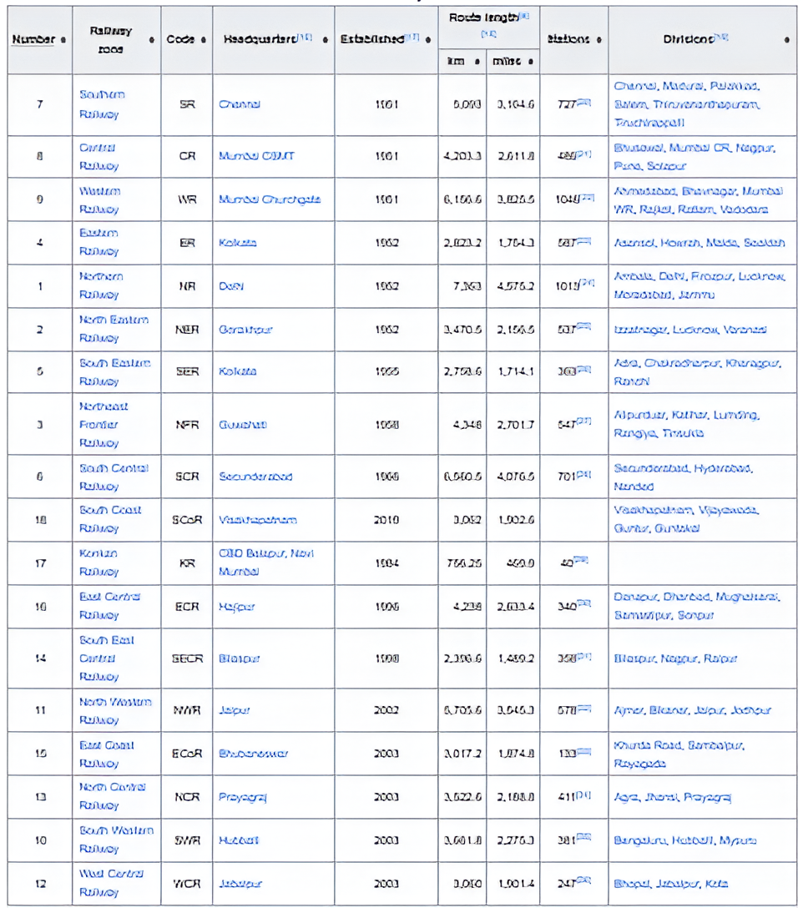

The railway system in India is the biggest in Asia and second largest in world under a
single management being next to the Soviet Railways. Indian Railways have a network of 62,000 km, with 34,000 km on broad gauge, 24,000 km on metre gauge and 4,000 km on narrow gauge. There are 7,500 stations of varying capacity. About 35,000 passenger bogies and 4,00,000 goods bogies are also ply in the track of Indian Railways. The Indian Railways carry a bout 80 lakhs of passengers and 7 lakhs tonnes of freight everyday. About 10 lakhs of people are employed in the Indian Railways.
3.1.3 Locomotives
In the year 2003–04, Indian Railways owned a fleet of 7817 locomotives including 45
steam locomotives, 4769 diesel locomotives, and 3003 electric locomotives. The number of steam locomotives reached its peak in 1963–64 with 10,810 units. It then declined gradually, as the production of steam locomotives was stopped in 1971. Diesel and electric locomotives, which are more than twice as powerful as steam locomotives, have progressively replaced steam locomotives. Owing to the heavy investments involved in replacing all the existing steam locomotives with diesel and electric locomotives, steam locomotives were gradually phased out, and it was decided that these should be retained in service till the expiry of their Service life or 2000 AD, whichever is earlier. Accordingly, most steam locomotives of the Indian Railways have been phased out. Apart from replacing steam locomotives with diesel and electric locomotives in areas of
heavy traffic density, a large number of diesel shunting engines are also being introduced as replacements for steam shunting locomotives. This has enabled Indian Railways to improve operational efficiency in both passenger and freight operations.
3.1.4 Production Units of Indian Railways
Apart from zonal railways, there are six production units. The details given in the
following table.
Unit
3.1.5 Classification of Indian Railways
The Railway Board has classified the railway lines in India based on the importance
of the route, the traffic carried, and the maximum permissible speed on the route. The
complete classification is given below
Broad gauge routes 119
All the broad gauge (BG) routes of Indian Railways have been classified into five
different groups based on speed criteria as given below.
Group
Sanctioned speed
* D Special and E Special routes based on the importance of routes, it has been decided that few selected routes presently falling under D and E routes will be classified as D special and E special routes. This has been done for the purpose of track renewal and priority allotment of funds.
3.1.6 Rail Gauges
Gauge of railway track is defined as the clear minimum horizontal distance between
the inner top faces of the two rails of a track. (Fig.3.1)
Fig.3.1 Rail gauge
3.1.6.1 Types of Rail Gauges
Various gauges on Indian Railways and its coverage are given below.
- Broad gauge,
- Standard gauge,
- Metre gauge,
- Narrow gauge
- Uniformity in Gauges
1. Broad gauge (BG)
When the clear horizontal distance between the inner faces of two parallel rails
forming a track is 1676mm (5‘6‖) the gauge is called Broad Gauge (B.G) This gauge is also known as standard gauge of Indian Railway and is the broadest gauge of the world. For greater the gauge, higher is the speed. Hence for higher speeds, broad gauge is preferred. Also broad gauge is more stable in running and accommodates more passenger/fright capacity and hence the intensity of the traffic is more and it is cheaper.
2. Metre gauge (MG)
When the clear horizontal distance between the inner faces of two parallel rails
forming a track is 1000mm, the gauge is known as Metre Gauge (M.G). If the intensity of traffic is more, metre gauge is not recommended. This gauge is, therefore, used for tracks in under-developed areas and in interior areas, where traffic intensity is small and prospects for future development are not very bright.
3. Narrow gauge (NG)
When the clear horizontal distance between the inner faces of two parallel rails
forming a track is either 762mm or 610mm, the gauge is known as Narrow gauge (N.G). This
gauge is, therefore, used in hilly and very thinly populated areas.
3.1.7 Uniformity in Gauges
The need for uniformity of gauge has been recognized by all the advanced countries
of the world. The ill-effects of change of gauge are numerous. The multi-gauge system is not
only costly and cumbersome but also causes serious bottlenecks in the operation of the
Railways and hinders the balanced development of the country. Indian Railways therefore took the bold decision in 1992 of getting rid of the multi-gauge system and following the unigauge policy of adopting the broad gauge uniformly. The conversion to uni-gauge will result in high initial expenditure, but it will be highly economical over a period of time,considering the following advantages.
(i) No transport bottlenecks
There will be no transport bottlenecks after a uniform gauge is adopted and this willlead to improved operational efficiency resulting in fast movement of goods and passengers.
(ii) No trans-shipment hazards 121
There will be no hazards of trans-shipment and as such no delays, no damage to goods,no inconvenience to passengers of transfer from one train to another train.
(iii) Provisions of alternate routes
Through a uni-gauge policy, alternate routes will be available for free movement of-traffic and there will be less pressure on the existing BG network. This is expected to result in preference to railway rather than road transport in long-haul transportation of passengers and goods.
(iv) Better turnaround : There will be a better turnaround of wagons and locomotives,and their usage will improve the operating ratio of the railway system as a whole. As a result the community will be benefited immensely.
(v) Improved utilization of track
There will be improved utilization of tracks and reduction in the operating expenses of the railway.
(vi) Balanced economic growth
The areas currently served by the MG will receive an additional boost, leading to the removal of regional disparities and balancing economic growth.
(vii) No multiple tracking works
(viii) Better transport infrastructure
Some of the areas served by the MG have the potential of becoming highly industrialized; The uni-gauge policy will help in providing these areas a better transportation infrastructure.
3.1.8 Loading Gauge
The loading gauge consists of a vertical post with a horizontal arm, from which a
curved frame is suspended. It is constructed at the exit of the goods yard as shown in
fig.3.2. Its main function is to confirm that the top of the loaded wagon would clear all the structures such as bridges, tunnels, etc., en-route its destination
Fig.3.2 Loading gauge 3.1.9 Construction Gauges
By adding the necessary clearance to the loading gauge, the construction gauge ensure
that vehicles can move safely at the prescribed speed without any obstruction/violation. The various permanent structures on railway lines such as bridges, tunnels, and platform sheds are built in accordance with the construction gauge so that the sides remain clear of the loading gauge.
3.2.1 General
The finished or completed track of a railway line is known as permanent way. It
essentially consists of the following three parts namely, Rails, Sleeper and Ballast, as shown in
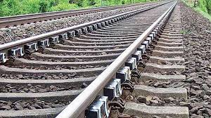

fig.3.3.
Rails are similar to ―I‖ section girder fixed in two parallel lines to form the track to provide a continuous level surface for the movement of trains.
Fig.3.3 Component parts of railway line
Two steel rails are fixed parallel on the sleepers by means of suitable fixtures and fastenings and at right angles to them. The sleepers are embedded in ballast which is spread over the formation ground. The rails should be strong and rigid enough to bear the wheel loads and impacts. Generally, they are made of high-carbon steel to withstand stresses.
3.2.2 Function of Rails
1. The rails should provide continuous and level surface for the movement of trains.
2. The rails should provide a smooth and uniform surface and should bear the heavy
loads transmitted through the wheels.
3. The rails should bear lateral stresses due to braking and thermal stresses as well.
4. The rails should transmit the load to the ballast formations through sleepers.
5. Wear of rails should be the least. 123
3.2.3 Requirements of an Ideal Rail
1. The rail should have the most economical section consistent with strength,
stiffness, and durability.
2. The rail shape should be such that fish-plates can easily be fitted.
3. The rail face should resist wear.
4. The rail should possess adequate lateral and vertical stiffness.
5. The rail should be made of proper composition of high-carbon steel.
6. The depth of head of rail should be sufficient to allow for an adequate margin of
vertical wear.
7. The centre of gravity of rail section should lie very near to the centre of height of
rail.
8. The height of the rail should be adequate for vertical stiffness and strength as a
beam
9. The rail section should conform the standards prescribed by the Indian Railways.
10. The head of rail should have adequate height to resist vertical shear.
3.2.4 Types of Rail Section
Fig.3.4 Rail sections
Rail sections can be classified into the following types:
1. Double-headed rail
2. Bull-headed rail
3. Flat-footed rail
1. Double-headed rail
The first rails used were double headed and made of an ―I‖ or dumb-bell section. For
fixing, each rail requires one chair per sleeper. The advantage of this type of rail was that when the head had worn out, the rail could be inverted and be used, thus economical. In practice, it was found that due to impact, the lower head got dented. The lateral stability was also very poor and hence, could not be used as head. This lead to be development of bull headed rail.
2. Bull-headed rail
Bull headed rail is similar in shape to double headed rail but with more metal added to
the head to withstand wear. The foot was just sufficient in size to bear the stress induced in it by the moving loads. The foot of the rails are fastened to chairs by wooden keys. Each rail required one chair per sleeper for fixing. It also had poor lateral rigidity.
3. Flat-footed rail
Flat-footed rail has the shape of inverted ―T‖(approx.). It is stronger than bull-headed
rail. It needs no chair and the foot of the rail may be spiked directly to the sleepers. The main advantage of this type of rail is its lateral rigidity. The heavy train load tends to sink the rail
into the sleepers. This causes loosening of the spikes when the flat footed rails sink directly to the wooden sleepers. To avoid this sinking and for distributing the load on wider areas, steel bearing plates are used between sleepers and rails.
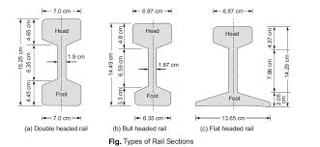

3.2.7 Length of Rails
Theoretically, the longer the rail, the lesser the number of joints and fittings required
and the lesser the cost of construction and maintenance. Longer rails are economical and provide smooth and comfortable rides. The length of a rail is, however, restricted due to the
following factors.
(a) Lack of facilities for transport of longer rails, particularly on curves.
(b) Difficulties in manufacturing very long rails.
(c) Difficulties in providing bigger expansion joints for long rails.
(d) Heavy internal thermal stresses in long rails.
Taking the above factors into consideration, Indian Railways has standardized a rail
length of 13 m (42 ft) for broad gauge and 12 m (39 ft) for metre and narrow gauge tracks.
Indian Railways is also planning to use 26 m, and even longer, rails in its track system.
3.2.6 Welding of Rails
Welding is the process of joining two or more pieces of metal together by heat with or
without the application of pressure.
1. Purposes of welding the rails
In railways the welding process is used for the following purposes.
a. To join the rails in order to increase their length. 125
b. To bring back the worn out and damaged rails, points, crossings, etc. to their
original shape and size. Thus increasing their life and reducing the cost of
replacement.
2. Advantages of welding of rails
a. The welded joints are stronger than any other method of joints.
b. The welded joints give a smooth working surface and good appearance.
c. Welding of rails considerably reduces creep.
d. The welded joints require less frequent inspection and lower maintenance cost.
e. Welding of rails offer better result in track circuit and electrified tracks.
f. The risk of sabotage is decreased because it is not possible to undo the welded
joints.
g. The welded rails maintain lateral, longitudinal and vertical stability of the track
better.
3. Methods of welding of rails
There are so many methods of welding in use. The common methods are as follows:
a. Gas pressure welding
b. Electric arc welding
c. Chemical or thermit welding
d. Flash-butt welding
3.2.7 Wear of Rails
It is the loss of shape of rail heads due to a number of consistent moving wheels on the
rails. In course of time, wear and tear occurs on vertical and horizontal planes of a rail head.
Wear occurs due to,
* Impact of moving loads
* Forces due to rail-wheel interaction
* Braking of wheels and
* Effects of weather
1. Types of wear on rails
The wear can be classified into the following three categories depending upon the
position of wear.
a. Wear on the top of the rail head (vertical wear)
b. Wear on the ends of the rail (battering of rail ends)
c. Wear on the sides of the rail head (lateral wear)
a. Wear on the top of the rail head (vertical wear) Fig.3.4 (a) vertical wear
The metal from the top face of a rail stretches and 'flows' when the stress in the rail exceeds
the elastic limits and the rail assumes the shapes as shown in fig.3.4 (a), forming projection
beyond the original section of the rail, known as ‗blurr‘.
Causes of vertical wear of the rail:
i. Due to the abrasion of the rolling wheels over the rail.
ii. The heavy load of a wheel is concentrated in a small area on the inner face of rail
which results in building of high stresses in rail exceeding the elastic limit.
iii. The grinding action of the same particles between wheels and rails.
iv. Due to corrosion.
b. Wear on the ends of the rail (battering of rail ends)
Fig.3.4 (b) battering of rail ends
The wear occurs at the end of rails as shown in Fig.3.4 (b) and is much greater than the
wear on the top of the rails. This wear is mainly due to the blow which the end of rail
receives when a wheel jumps the gap between two rail ends. The rails are battered by such
blows. 127
i. On curves, the centrifugal force causes thrust of the wheel flanges against the inner
side of the outer rail head, which results in the grinding of the rail by the flanges
causing side wear.
ii. On curves, the vehicles do not bend to the shape of the curvature, resulting into
biting the inner side of the outer rail head by wheel flanges.
iii. Wear on inner side of the head of inner rail also occurs due to slipping and skidding
of wheels on curves.
c. Wear on the sides of the rail head (lateral wear)
Fig.3.4 (c) lateral wear
2. Measures to reduce wear of rails
Some of the methods adopted to reduce vertical wear and lateral wear on straight
paths and curves are listed below.
a. By reducing the number of joints by welding
b. By using the bearing plates
c. By the use of special alloy steel for rails.
d. By adopting good maintenance of track.
e. By reducing the expansion gap.
f. By using proper lubricants.
g. By adopting inner exchange of inner and outer rails.
h. By introducing check rails on sharp curves.
3.2.8 Coning of Wheels
If the track of the wheels rest flat on the rails, there will be lateral movement of the
axle. This results in the damage to the inside faces of the head of the rails. This is prevented by sloping the tread at a slope of 1 in 20. This sloping of the wheels from the vertical axis is known as coning of wheels. (Fig.3.5). coning Flange Tread Axle Sleeper
Rail
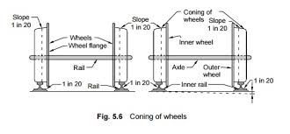

Fig.3.5 Coning of wheels
As the wheels and the axle are monolithic, on curves the coning of wheels help the
outer wheel to cover a large distance without slipping than the inner wheel, for the same number of revolution. Also, the vehicle is maintained at the centre of its run by coning of wheels.
3.2.9 Hogged Rails
Due to the battering action of wheels over the end of rails, the rails get bent down and
deflected at ends. The rail with this defect is called hogged rail. Besides, rail ends get hogged due to poor maintenance of the rail joint, yielding formation, loose and faulty fastenings, and other such reasons. Hogging of rails causes the quality of the track to deteriorate. This defect can be remedied by measured shovel packing.
3.2.10 Bending of Rails
On course, the rails should be bent true to the curvature of the curve. In flat curves (less
than 3°) the rails need no bending as they are retained in curved position by the sleepers. The sleepers in turn, are held by the ballast heaped up at their ends and flush with the top of sleepers. The filling up of ballast in this manner is known as boxing. For curves morethan 3°, it is desirable to bend the rails to the correct curvature before fastening them to the sleepers.
Otherwise, elbows would occur at the joints, as the joints are less flexible in the horizontal direction.
3.2.11 Creep of rails
Creep is defined as the longitudinal movement of the rails in a track. Creep is common
to all railway tracks, but varies considerably in magnitude.
1. Causes of creep 129
Rail
Anchor
Wedge
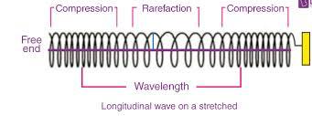

Fig.3.6 Wave motion in loaded rail
a. Development of wave motion in the rails (fig.3.6)
b. Forces acting at the time of starting accelerating, slowing down or stopping the
train.
c. Unequal expansion and contraction of rails due to temperature variations.
d. Use of low quality sleepers.
e. Improper fixing of rails.
f. Improper maintenance of track.
g. Uneven spacing of sleepers.
h. Insufficient ballast.
i. Inadequate drainage arrangements
2. Effects of creep
a. Dislocation of sleepers affecting the gauge and alignment of track.
b. Excess opening of rail joints develops considerable stresses in fish plates and bolts,
thus rendering their breakages.
c. In some places at joints, the jamming prevents expansion tending buckling of rails.
d. Distortion of points and crossings affect the gauge and alignment. The movement
of switches made difficult and interlocking is thrown out of gear.
3. Methods of correcting creep
The following four methods can be used to correct the creep of rails.
a. Pulling back of rails
b. Providing steel sleepers
c. Providing anchors or anti-creepers
d. Efficient and proper maintenance of track.
(a) Anchor location or one-way traffic (b) Wedge anchor
(b) Anchor location or two-way traffic
(a) Spring anchor
Fig.3.7 Creep of rails -Anchor and location
Rail
Anchor
Direction of
movement
Anchors
a. Pulling back of rails
When creep has sent in, the rails are pulled back to their original positions.
b. Providing steel sleepers
Sleepers should be of such type and with such fittings that they prevent the rail from
creeping on them. Also, the sleepers must have a good grip in the ballast to resist the
movement of the sleeper itself in the ballast. Increase in the number of sleepers will help in the prevention of creep.
c. Providing anchors or anti-creepers
These are fastened to the foot of the rail and are in absolute contact with the side of the sleeper on the side opposite to the direction of creep. If creep is taking place in both
directions, anti-creepers are provided on both sides of the sleeper (fig.3.7).
d. Efficient and proper maintenance
Frequent inspection and proper maintenance of tracks will considerably reduce amount
of creep of rails. Use of more amount of clean ballast minimises creep to a very great extent. 131
CHAPTER 3.3 SLEEPERS AND BALLAST
3.3.1 General
Sleeper is a transverse ties that are laid to support the rails. The main fun

UNIT-V
CHAPTER -5
Track geometrics, Construction and Maintenance

Track geometry is concerned with the properties and relations of points, lines, curves, and surfaces in the three-dimensional positioning of railroad track. The term is also applied to measurements used in design, construction and maintenance of track. Track geometry involves standards, speed limits and other regulations in the areas of track gauge, alignment, elevation, curvature and track surface Standards are usually separately expressed for horizontal and vertical layouts although track geometry is three-dimensional.

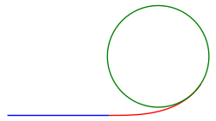
Layout

Horizontal layout
Tangent track in blue with transition spiral in red and curved track in green.
Horizontal layout is the track layout on the horizontal plane. This can be thought of as the plan view which is a view of a 3-dimensional track from the position above the track. In track geometry, the horizontal layout involves the layout of three main track types: tangent track (straight line), curved track, and track transition curve (also called transition spiral or spiral) which connects between a tangent and a curved track. Curved track can also be categorized into three types. The first type is simple curve which has the same radius throughout that curved track. The second type is compound curve which comprises two or more simple curves of different radii that have the same direction of curvature. The third type is reverse curve which comprises two or more simple curves that has the opposite direction of curvature (sometime known as "S" curve or serpentine curve).[3][4]
In Australia, there is a special definition for a bend (or a horizontal bend) which is a connection between two tangent tracks at almost 180 degrees (with deviation not more than 1 degree 50 minutes) without an intermediate curve. There is a set of speed limits for the bends separately from normal tangent track.[5]

Vertical layout
Vertical layout is the track layout on the vertical plane. This can be thought of as the elevation view which is the side view of the track to show track elevation. In track geometry, the vertical layout involves concepts such as crosslevel, cant and gradient.

Reference rail
The reference rail is the base rail that is used as a reference point for the measurement. It can vary in different countries. Most countries use one of the rails as the reference rail. For example, North America uses the reference rail as the line rail which is the east rail of tangent track running north and south, the north rail of tangent track running east and west, the outer rail (the rail that is further away from the center) on curves, or the outside rails in multiple track territory.[6] For Swiss railroad, the reference rail for tangent track is the center line between two rails, but it is the outside rail for curved track.[7]

Track gauge
Main article: Track gauge
Track gauge or rail gauge (also known as track gage in North America[8]) is the distance between the inner sides (gauge sides) of the heads of the two load bearing rails that make up a single railway line. Each country uses different gauges for different types of trains. However, the 1,435 mm (4 ft 8+1⁄2 in) gauge is the basis of 60% of the world's railways.

Transverse elevation

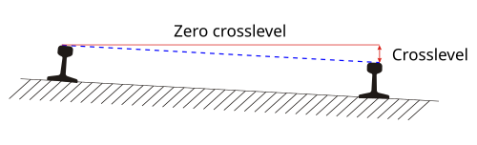
Crosslevel
The measurement of crosslevel between two rails
Crosslevel (or 'cross level') is the measurement of the difference in elevation (height) between the top surface of the two rails at any point of railroad track. The two points (each at the head of each rail) are measured at by the right angles to the reference rail. Since the rail can slightly move up and down, the measurement should be done under load.
It is said to be zero crosslevel when there is no difference in elevation of both rails. It is said to be reverse crosslevel when the outside rail of curved track has lower elevation than the inside rail. Otherwise, the crosslevel is expressed in the unit of height.
The speed limits are governed by the crosslevel of the track. In tangent track, it is desired to have zero crosslevel. However, the deviation from zero can take place. Many regulations have specification related to speed limits of certain segment of the track based on the crosslevel.[8][9]
For curved track, most countries use the term cant or superelevation to express the difference in elevation and related regulations.

Warp
Warp is the difference in crosslevel of any two points within the specific distance along the track. The warp parameter in the track geometry is used to specify the maximum in the crosslevel difference of the track in any segment (tangents, curves and spirals).
Without the maximum warp parameter, the regulation on crosslevel alone may not be sufficient. Consider rails with a positive crosslevel followed by a negative crosslevel followed by a sequence of alternating positive and negative crosslevels. Although, all of those crosslevels are in permissible parameter, when operating a train along such track, the motion will be rocking left and right. Therefore, the maximum warp parameter is used to prevent the critical harmonic rock-off condition that may result in the trains rocking back and forth and derailing following wheel climb.[9]
In North America, the specific distance used for measurement to ensure that the difference in crosslevel of the track is within the permissible warp parameter is 62 feet. The design warp is zero for both tangent and curved track. That means, ideally, the crosslevel should not change between any two points within 62 feet. There are some deviations to allow crosslevels along the track to change (such as change for superelevation in curves). Different levels of those deviations from the zero warp specify the speed limits.[8]
The specification that focuses on the rate of change in crosslevels of curved track is contained within the area related to cant gradient.

Longitudinal elevation

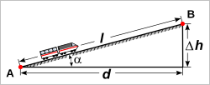

Track gradient

- d: distance traveled horizontally
- Δh: rise
- l: slope length
- α: angle of inclination
Main article: Grade (slope) § Railways
Further information: Ruling gradient
The term track gradient is relative elevation of the two rails along the track. This can be expressed in the distance traveled horizontally for a rise of one unit, or in terms of an angle of inclination or a percentage difference in elevation for a given distance of the track.
The allowable gradients may be based on the ruling gradient which is the maximum gradient over which a tonnage train can be hauled with one locomotive. In some countries, momentum gradient which is a steeper but shorter gradient may be allowed. This is usually when a track gradient connects to a leveled tangent track long enough and with no signal between them such that a train can build momentum to push through a steeper grade than it can without the momentum gained on the leveled tangent track.
In curved track (with or without cant), there will be curve resistance to push the trains through the curve. The allowable gradients may be reduced on curves to compensate for the extra curve resistance.[5] The gradient should be uniform along the track.

Vertical curve
Vertical curve is the curve in vertical layout to connect two track gradients together whether it is for changing from an upgrade to a downgrade (summit), changing from a downgrade to an upgrade (sag or valley), changing in two levels of upgrades or changing in two levels of downgrades.
Some countries do not have specification on the exact geometry of vertical curves beyond general specification on vertical alignment. Australia has specification that the shape of vertical curves should be based on quadratic parabola but the length of a given vertical curve is calculated based on circular curve.[5]

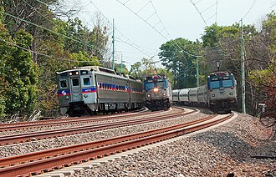
Curvature
Curve with superelevation of tracks on the Keystone Corridor near Rosemont, Pennsylvania
Curvature refers to the amount by which a curve deviates from being a straight line. In the context of railway tracks, it is the measure of how much the track deviates from a straight path. It is essential in designing safe and efficient rail systems. In railways, curvature impacts the speed and safety of trains, as sharper curves require slower speeds to avoid derailment. The formula for curvature in a curve is typically defined as the inverse of the radius of the curve.
Curves are essential in railway tracks as they allow trains to navigate various geographical and urban obstacles that make straight routes impractical or impossible. Natural terrains, such as mountains, valleys, and rivers, require railways to adapt to existing landscapes, which is achieved through carefully designed curves. Additionally, in cities and populated areas, tracks must curve to fit within limited spaces or avoid buildings and other infrastructure. Curved tracks help railways maintain an efficient layout that minimizes land disruption and follows the natural or urban environment.
In most countries, the measurement of curvature of curved track is expressed in radius. The shorter the radius, the sharper the curve is. For sharper curves, the speed limits are lower to prevent an outward horizontal centrifugal force to overturn the trains by directing its weight toward the outside rail. Cant may be used to allow higher speeds over the same curve.
The curvature of railway tracks significantly affects train dynamics by influencing stability, safety, and performance.
- Centrifugal force and stability: When a train navigates a curve, centrifugal force acts outward, which can destabilize the train. To counter this, tracks are often tilted (superelevation) to balance the force.
- Wheel-rail interaction: Tight curves can cause higher lateral forces between wheels and rails, increasing wear and the risk of derailment.
- Speed limitations: Curves require speed restrictions to ensure the train remains stable and comfortable for passengers.
- Transition curves: Gradual transition curves, such as Euler spirals, are used to minimize sudden changes in curvature, reducing acceleration shocks and improving ride quality.
In North America, the measurement of curvature is expressed in degree of curvature. This is done by having a chord of 100 feet (30.48 m) connecting to two points on an arc of the reference rail, then drawing radii from the center to each of the chord's end points. The angle between the radii lines is the degree of curvature.[10] The degree of curvature is inverse of radius. The larger the degree of curvature, the sharper the curve is. Expressing the curve in this way allows surveyors to use estimation and simpler tools in curve measurement. This can be done by using a 62-foot (18.90 m) string line to be a chord to connect the arc at the gauge side of the reference rail. Then at the midpoint of the string line (at the 31st foot), a measurement is taken from the string line to the gauge of the reference rail. The number of inches in that measurement is approximated to be the number of degrees of curvature.[8]
Due to the limitation of how specific train equipment can make a turn at maximum speeds, there is a limitation of minimum curve radius to control the sharpness of all curves along a given route. Although most countries use radius for measurement of curvature, the term maximum degree of curvature is still used outside North America such as in India, but with the radius as the unit.[11]

Cant
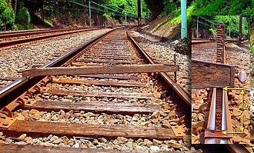
Main article: Cant (road/rail)
Railroad track spirit level in place indicating 5 in (130 mm) of superelevation between the inside and outside rails of a curve along the Keystone Corridor near Narberth, Pennsylvania
In curved track, it is usually designed to raise the outer rail, providing a banked turn, thus allowing trains to maneuver through the curve at higher speeds that would otherwise be not possible if the surface was flat or level. It also helps a train steer around a curve, keeping the wheel flanges from pressing the rails, minimizing friction and wear. The measurement of the difference in elevation between the outer rail and the inner rail is called cant in most countries. Sometime the cant is measured in term of angle instead of height difference.[12] In North America, it is measured in height difference and called crosslevel, even for the curved track.
When the outside rail is at higher elevation than the inside rail, it is called positive cant. This is normally the desired layout for curved track. Most counties achieve the desired level of positive cant by raising the outside rail to that level which is called superelevation. For Swiss railroads, the cant is done by rotating at the track axis (center of the two rails) to have outside rail super elevated (raised) at the half rate of the desired cant and the inside rail under elevated (lowered) at the same half rate of the desired cant.
When the outside rail is at lower elevation than the inside rail, it is called negative cant (or reverse crosslevel in North America). This is not usually a desired layout but it may be unavoidable in some situations such as curves involving turnouts.
There are regulations which limit the maximum cant. This is to control the unloading of the wheels on the outside rail (high rail), especially at low speeds.

Cant gradient
Cant gradient is the amount by which cant is increased or decreased in a given length of track. The change in cant is required in order to connect a tangent track (no cant) to a curved track (with cant) through a transition curve. The rate of change of cant is used to determine the suitable cant gradient for a given design speed. Track twist may also be used to describe cant gradient which may be expressed in percentage of cant change per length unit.[7] However, in the UK, the term track twist is normally used in the context of cant gradient with higher values which are considered to be faults.[12]
In North America, the required cant gradient on a transition curve to achieve smooth connection between superelevation of curved track and the zero crosslevel of tangent track is called superelevation runoff. In addition to the runoff specification, the regulations related to allowable rate of change in the cant is also part of the general specification on the rate of change in crosslevel called warp parameter. The warp parameter and superelevation runoff help calculate the required length of the runoff for a transition curve.[9]

Cant deficiency
Main article: Cant deficiency
As described, cant may be used to reduce lateral acceleration on trains traveling on curved track. This is to balance the centrifugal force (force pushing outward the curve) and centripetal force (force pushing inward the curve). At a higher speed, the centrifugal force is higher. On the contrary, higher cant creates the higher centripetal force. The calculation for this assumes a constant train speed on a constant radius curve.
When the speed of the train and the amount of cant are in balance (centrifugal matches centripetal), it is called equilibrium. This would make the components of wheel to rail force normal to the plane of the track having the same in aggregate for the outside rail as for the inside rail. This would also make the passengers in the train not to perceive any lateral acceleration (a push toward sideway).
For a fixed amount of cant, the speed that creates balance is called equilibrium speed. For a constant speed of a running train, the amount of required cant to achieve the balance is called equilibrium cant.[12]
In practice, trains are not running on equilibrium cants at curves. The situation is called unbalance, which can be in one of the two following ways. For a given speed, if the actual cant is less than the equilibrium cant, the amount of cant difference is called cant deficiency. In the other word, it is the amount of missing cant to achieve the balance. On the contrary, for a given speed, if the actual cant is higher than the equilibrium cant, the amount of over cant from the balance is called cant excess.
In a shared track configuration for trains with different operating speeds such as freight and higher-speed rail passenger services, the cant on a curve should be considered for both high and low speeds. The higher-speed trains would experience cant deficiency and the lower-speed trains would experience cant excess. These parameters have a significant effect on curve performance which includes safety, passenger comfort, and wear and tear of equipment and rails.[13]

Alignment
The term alignment is used in both horizontal and vertical layouts to describe the line uniformity (straightness) of the rails.
The horizontal alignment (or alinement in the United States) is done by using a predefined length of string line (such as 62-foot in the US and 20 meters in Australia[5]) to measure along the gauge side of the reference rail. It is the distance (in inches or millimeters) from the midpoint of the string line to the gauge of the reference rail. The design horizontal alignment for tangent track is zero (perfect straight line on the horizontal layout). The design horizontal alignment on the curved track in North America is 1 inch for each degree of curvature. Any other readings indicate deviations.
The vertical alignment (or profile in North America, but not to be confused with rail profile) is the surface uniformity in the vertical plane. The measurement of uniformity is done using a predefined length of string line (normally the same length used in horizontal alignment) along the track. If the midpoint of the measurement has higher elevation, it is called hump deviation. On the other hand, if the midpoint has lower elevation, it is called dip deviation.[9]
These deviations from design alignment are used as parameters to assign speed limits.
CONSTRUCTION AND MAINTENANCE OF RAILWAY TRACK
The construction of railway lines is a complicated, challenging and interestingactivity of civil engineering. Most of the present railway lines were built by the Britishduring the latter half of the 19b century. After independence, the Indian Railways havetaken up some challenging tasks, which involved large bridges, tunnels and laying oftracks in hilly terrain. Recently, the Indian Railways have accomplished theconstruction of the konkan Railway over a length of 700 km, which involved manytunnels, bridges, and massive earthwork. The conversion of the metre gauge to broadgauge is yet another challenging task undertaken by the railways now. The doubling ofmany trunk routes is also a commendable achievement.
The construction of a railway line covers the following major activities:
1. Earthwork
2. Drainage
3. Bridges
4. Tunnels
5. Track laying
Earthwork
Laying a railway line involves a considerable amount of earthwork. Earthworkinvolves cutting and formation of embankment. These operations are preceded byclearing and grubbing, which, involves removal of shrubs and cutting of trees fromwithin the designated areas. Roots and stumps are also removed to a nominal depthbelow the existing ground.DrainageWater is one of the most unwanted commodity in a railway track and must bedrained off and efficiently as possible. Water comes as surface run-off from rains.Water from seepage in cut sections and by capillary action from below.The capillary rise of water can be arrested by having a blanket of sand or coarsematerial below the ballast layer. Water cannot rise in a medium having such coarse
fraction. In a soil having predominantly clayey fractions, capillary rise can be a serious
problem. An example of such a soil is the black cotton soil found in many parts of the
country.
Bridges
Bridges have many unique features. Since they are exclusively meant for railwaymovement there is no need for pedestrians to be accommodated. For providing safety togangmen and maintenance staff, a safe refuge may be given at convenient intervals.When steel bridges are used the sleepers are laid on the girders and fastened to them,dispensing with the ballast. When RCC, prestressed concrete or masonry arch bridgesare adopted, ballast is provided under the sleepers.
Tunnels
Tunnels are needed for negotiating hills, which fall in the alignment and wheredetours are costly or not feasible. When the excavations become deep anduneconomical, it is economical to opt for a tunnel. The Mumbai-Pune railway line andthe recently commissioned Konkan Railway have numerous tunnels.The alignment of a tunnel should be preferably straight, but many tunnels existwhich are on curves. The gradients of the track should be gentle. Even though siteconditions do not require a grade, a gentle grade facilitates quick drainage. Tunnels inhard rock do not normally need any lining. But tunnels in soft strata always need alining. A concrete lining is the standard practice.
Laying of Track
The work of laying a railway track on a prepared formation is known as platelaying. It is, the normal practice to initially lay the sleepers and the rails directly on theformation without placing the ballast. This is done so that the track can settle in theinitial stages when the embankment is still in a loose state. Ballast is packed subsequently.The point, up to which the track has been laid, is known as the railhead. Thepoint from which the track is started is known as the base.
There are three common methods of plate laying:
1) Side method (also known as tram line method)
2) Telescopic method
3) American Method
The side method is followed when there is a track already by the side of the newtrack to be laid. This is the case when a track is to be doubled. The track materials arecarried in special material trains and dumped on the new formation. The track is thenassembled. Sleepers are laid out and the rails are fastened. If a track does not exist, thematerials are carried by road or over a temporary rail line.The telescopic method uses the track already laid to transport the material. Thefresh material is then assembled in front of the track already laid and connected to it.Fresh material is brought by wagons on the newly laid track. The works proceed inshort stretches, forming sub-depots as the work proceeds. The work may be carried out
by specialised gang of labour, grouped as :
1) Material gang for unloading and carrying of track materials;
2) Linking gangs for fixing sleepers, rails and fastening; and
3) Packing gangs for packing the earth underneath the sleepers and bringing the
track to proper profile and alignment.The American method involves assembling the sleepers and rails in units at acentral workshop, moving the assemblies to site and linking. The work is highlymechanised using equipment for loading and unloading and transporting.
RAILWAY MAINTENANCE
Importance of Maintenance
The need for and the importance of railway maintenance arise out of the
following considerations:
1) The track rests on a yielding foundation of ballast. As a result the track settles
over a period of use and it needs to be restored to design level constantly.
2) The track is subjected to severe dynamic loads, which set up vibrations in the
track and cause it to lose its geometry. Restoraticn of track parameters becomes a
continuous requirement.
3) The various track elements are subjected to wear due to traffic. For example,
the fishplates and fastenings undergo considerable wear and tear. When these get worn
out, the track loses its rigidity, gauge, profile and alignment. The ballast stones get
abraded and crushed. The sleepers get worn out.
4) Environmental factors add to the wear of track and damages to the permanent
way. The influence of wind, rain, floods and temperature variation on track elements is
also damaging.
5) The maintenance of an accurate gauge is the key to safety of rail movement.
Accidents can be disastrous.
6) A well maintained track gives comfortable ride.
7) Energy consumption on a well-maintained track is low.
Maintenance of Formation
As the wheel loads have tended to increase over the years since the railway lineswere built more than a century ago, the formation is being subjected to heavy stresses.Intrusion of soil into the ballast is common. The situation can be remedied by providinga blanketing layer of sand below the ballast.Maintenance of Drains Pre-monsoon clearance of siltation and vegetation growth in drains is of greatimportance. The performance of drains during the monsoons must be watched andrectification of defects after cessation of rains must be done.
Bridges and Culverts
Pre-monsoon inspection and close vigilance during rains of bridges and culvertsis part of good maintenance. The performance of bearings, the condition of protectiveworks (guide bunds, flooring and curtain walls), evidence of scour and cracks in thestructural components - these are some of the items that deserve close inspection.
Maintenance of Fastenings
Screws, spikes and keys must be tightened and secured periodically. Worn outcomponents should be replaced. Base plates wear out due to constant rubbing of rail.They must be inspected and defective ones replaced.

